********************WORK IN PROGRESS********************

# Welcome

Welcome to the information security champion training and basic assessment curriculum. The current working title for this project is OctoC - Curriculum for Creating Cyber-Security Champions and Compliance Checking in Civil Communities (***Yes we know we used the word "Cyber" but the acroynm was tricky to think up - open to better suggestions! :)***).

## Who is this curriculum for?

This curriculum is designed as a tool for trainers working with people within small NGOs and media organisations who find themselves tasked with the management of the day to day running of secure and private information.

Often these individuals are described as "champions." These people begin this often informal role by being the office "techie" or "printer-fixer" - a person who might not have recieved formal training before but find themselves dealing with many of the day to day information security concepts.

Though most of the learning will be hands-on and participants won't need to be technical specialists to understand, this course is primarily about taking people who already understand some core concepts and giving them more skills to be able to manage more effectively.

At a minimum we suggest that participants already have a basic knowledge of tools and techniques listed in or already conducted trainings similar to the content found resources such as:

* [Level-Up](https://level-up.cc/)
* [Security in a Box](https://securityinabox.org)
* [Surveillance Self Defence](https://ssd.eff.org)
* [Umbrella App](https://wwww.secfirst.org)

## Why create this course?

This course was created to help fill an identified need within the trainer community. We currently have many resources available for educating users (such as [Level-Up](https://level-up.cc/)), for implementing issues of organisational sececurity ([OrgSec community)](https://orgsec.community/#all-updates) and for auditing an organisation's security ([SAFETAG](https://safetag.org)). What we were missing though, was a curriculum to help people beging to learn how to manage an organisation's information security. That is what this curriculum aims to provide.

## How does it work?

The range of knowledge needed to manage information security is enormous and often outside the realm of what any individual could master even with years of training. As such, the curriculum is designed to:

* Introduce individuals to a topic
* Develop a familarity with key approaches to dealing with the topic within their environment through class interaction and hands on research
* Leave a topic with a basic knowledge, resources and a developed support network that they can utilise for implementation at a later stage.

Throughout the course, each participant also conducts a basic assessment of their own organisation that they build on for each module that they cover. This helps to a participant to maximise the utility of the course to their own circumstances and leave with an action plan for implementation at a later stage. So for example, a module on privacy will introduce some core concepts, then individuals conduct group work on what's relevant for their individual circumstance, assess how their own organisations deal with the issue and then record this and recommended actions in their assessment for use at a later date.

This trainer curriculum follows the standard pedagogy approach to adult learning adopted by many within the information security training community - such as [Level-Up](https://level-up.cc/before-an-event/using-levelup-trainers-curriculum/).

This breaks down each lesson into the following five areas:

* Activity - a learning task for the group to conduct
* Discussion - about the module
* Inputs - related lecture or background material
* Deepening - the hands-on portion of the module
* Synthesis - summary and wrap-up. For this curriculum, this is also where participants fill out the assessment.

## How long does it take?

The course is designed to be modular. Allowing individual modules to be taken alone or a full course to be run. How long the course takes depends on many factors such as language, existing skills etc. However, we aim to make the entire course last at most five days.

## What does it cover?

It is not just about digital issues, but also addresses things such as the security of physical information like paper documentation. We also discuss the important issues of how to design projects to ensure responsible collection of data and the ensuring privacy by design within projects.

The course is broken into the following sections:

• [Introduction](introduction.md)  
• [Mapping information, assessing the threat environment and modelling](mapping.md)  
• [Privacy regulation and requirements](privacy.md)  
• [User Education](education.md)  
• [Encryption, Patching, Licensing](encryption.md)  
• [Network Management, Monitoring, WiFi and Logs](network.md)  
• [Communications](communications.md)  
• [Web and Email Management](webandemail.md)  
• [Password Management](passwords.md)  
• [Mobile Device Management / BYOD](byod.md)  
• [Travel](travel.md)  
• [Resilience and Backups](resilience.md)  
• [Policy Creation and Implementation](policy.md)  
• [Physical Security](physical.md)  
• [Responding to Incidents](incidents.md)  
• [Basic audits](audits.md)  
• [Community structures and resources for further learning](community.md)

## Licence

This work is licensed under the Creative Commons Attribution 4.0 International License. To view a copy of this license, visit http://creativecommons.org/licenses/by/4.0/. # Mapping information, conducting threat modelling and managing risk

### Introduction

Providing effective information security is often a delicate balance. Threats can often be varied and information about them can be confusing or incomplete. Resources are also limited, so organisations need to concentrate on dealing with risk in the most effective way that they can.

This module provides a starting point for the course and to create a framework for thinking and addressing choices made in other modules.

### Learning Goals

* Understand what information (both digital and physical) that they use in their work, where it is stored, who has access to it, who might want to access it and how to map it out
* Have a clear understanding of the differences between likelihood, impact, risk and mitigation
* Have located and utilised resources for understanding and accessing their own threat environment
* Understand the challenge of creating an effective information security policy within an organisation

### Assessment Goals

* Have created an information map for their organisation
* Add generic and localised threat resources (where available) to their threat assessment
* Have divided their information into easily understandable traffic light map with corresponding mitigation measures

### Recommend Preparations

* Mapping is best done physically using flipcharts and/or post-it notes
* Participants should have access to secure wifi
* It may be useful for have a shared hackpad or other document that will allow participants to ensure any new resources that they may find.
* It is helpful for the trainer to have already have an understanding of any localised threats already faced within the countries and/or organisations that the participants are from. In the "Deepening" section, a number of case studies should be selected. Ideally these will have public information already known about them (e.g media reports), so that the participants will be able to research the topics and make recommendations themselves. It is suggested to use some of the locations in the "Resources" section for this.

### Suggested Time

75 Minutes

### Notes

* Occassionally the participants in this module may end up driving the conversation into being completely being about digital information. It is important to ensure that participants also consider physical information - including things such as the storage of paper files, secure diposal of sensitive waste, the importance of caution in physical conversations etc.

## Activity

Break participants into groups, provide them with a flipchart and/or post-it notes and ask them to ask answer the following questions.

Where possible, each answer should be scaled from most to least sensitive etc.

* What information does their organisation store?
* Where do they store that information?
* Who has access to that information?
* Why do they have access to that information?
* What adversaries may wish to access that information?
* How might an adversary access that information?
* What mitigation measures can we take to protect that information?

The participant should then record the information into their own assessment sheet or document.

## Discussion

* What information security breaches or threats have we experienced or heard about?
* How did we react to those informations security breachs?
* How do we think we would react to those information security breachs?
* What security policies do we have in place already?
* What problems have we seen with the implementation of security policies?
* How might we overcome these implementation policies?
* What soures of information do we use for keeping up-to-date on security threats?

## Inputs

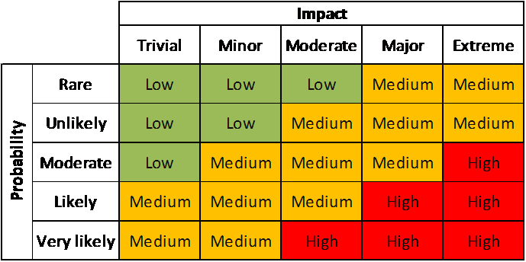

Probability and Impact Matrix

The trainer should demonstrate a simplified version of how to access risk.

Risk is the liklihood that something will happen multiplied by the impact if that it does happen. This concept can often be confusing to be people addressing it for the first time, especially if a trainer attempts to immediately attach numbers to each part. One way to make it easier to understand initially is by drawing a horizontal and then vertical line at a 90 degree angle, like a two sided triangle. Name one line "likelihood" and the other "impact."

Participants should then each be given a post-it note, asked to think of an information security risk and then place it on the chart depending on where they think the risk should fit before any mitigation measures are taken. They should then be asked to name some mitigation measures and then move the post-it note to where they think it should be after implementing them.

The objective for this activity is to ensure a participant realises that risk by reduce by either or both reducing likelihood or reducing impact. Often people tasked with managing risk tend to concentrate on only one of these two factors.

If the participants feel comfortable with the concept the trainer can then introduce more formalised ways of measuring risk, such as a simplified "risk register." The trainer should demostrate how to fill out a register using a couple of examples. If they are using numbers (1 to 5) or levels ("Low, Medium or High") to measure likelihood etc, it is useful to ask the participants to provide their opinion and then select the average. This technique helps ensure that risk registers suffer less from individual biases.

Individuals can now start to add topics they feel are specific risks to them into the risk register but we will wait until the "Deepening" to start looking at measuring the risks through threat modelling.

## Deepening

### Threat Modelling Reseach

This section focuses on participants on researching information security threats that already have occurred in countries or within organisations similar to their own. From this they will have to make assessments of the mitigations that they would need to take to reduce any potential similar risks.

* On a flipchart, ask participants what resources they use for keeping up-to-date on information security issues. An example would be reports by Citizen Lab.
* Ask them to provide an opinion on the usefulness of each of the resources that they mention. Including topics such as:
  + How up-to-date they are
  + How easy they are to read, understand and draw information from
  + How applicable they are to the context of the participants
  + What languages they are in
  + Other useful information
* Ask participants what well known information threats they are aware of that have affected organisations similar to their own.

The group will be broken down into teams and asked to use the suggested (or other) resources they have collected to go out and research an information security threat that is relevant to their work. They will be asked to report back on the threat addressing such issues as:

* What was the threat?
* Who did it effect?
* Why were they targetted?
* How did it effect the individuals or organisations?
* How could the likelihood be mitigated?
* How could the impact be mitigated?
* What residual risk would the participants face if they were targetted by this method?

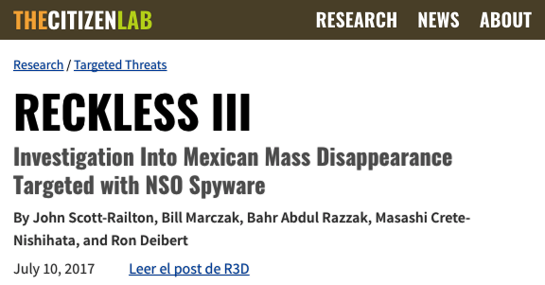 For example: In July 2017 Citizen Lab reported that a group of investigators into mass disapperances in Mexico were targeted with spyware developed by the NSO Group. Participants could be asked to research this case study with available resources and then propose mitigation measures.

Source: "Reckless III: Investigation Into Mexican Mass Disappearance Targeted with NSO Spyware" https://citizenlab.ca/2017/07/mexico-disappearances-nso/

Trainer Note:

* It may not be possible to find case studies that closely match the profile of the participants in the room. In that case it can often make sense to open the research to include regional threats, as often trends are likely to spread.
* If a participant was involved in one of the cases being research, it may make sense to have them not involved in the research on it, instead have another group research on it, provide their recommended solutions and then use the knowledge of the individual to add to the debrief.

## Synthesis

Participants should turn to their assessment documentation and consider how their organisation deals with the subject matter covered in this module. Where necessary they should ask questions and work with other participants to identify any:

* Issues they have found that effect their organisations
* Possible solutions they have learned
* Possible difficulties they may face in implementation (ideally using the time ad experience of trainers and other participants)
* Things would need to overcome these difficulties
* Connections to other organisations or individuals that would help them
* Timeline, resources and costs for implementation

This should be noted in their assessment, for future use.

In line with keeping this curriculum as an updated community tool, we would also ask that participants provide comments, feedback and new ideas for this module on the project website and/or Github!

TODO: - add

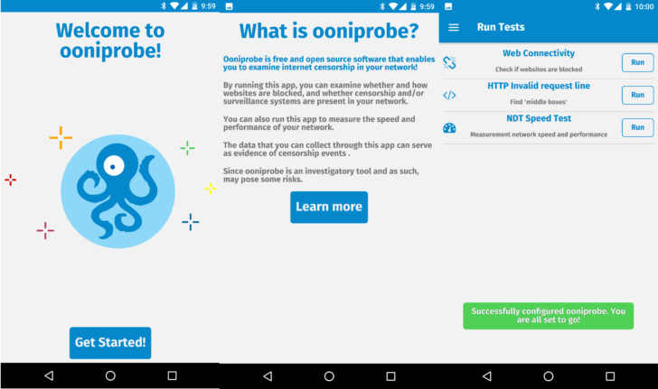  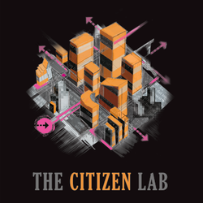  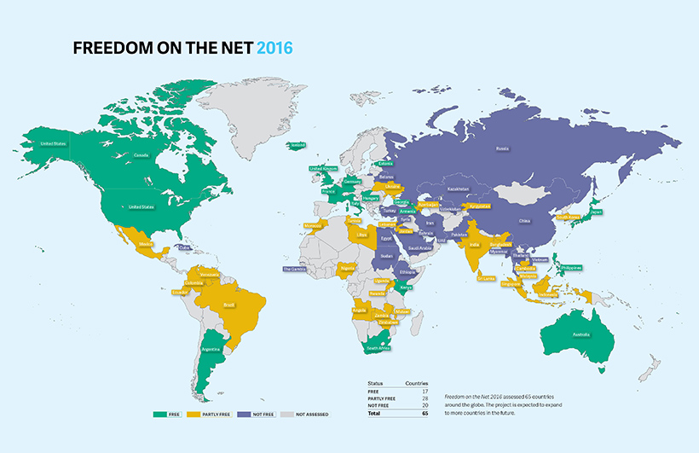

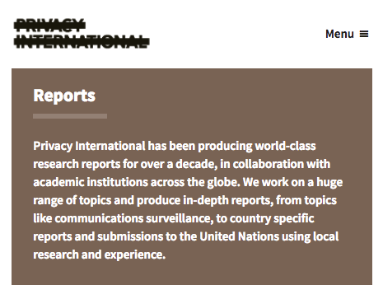

Privacy International

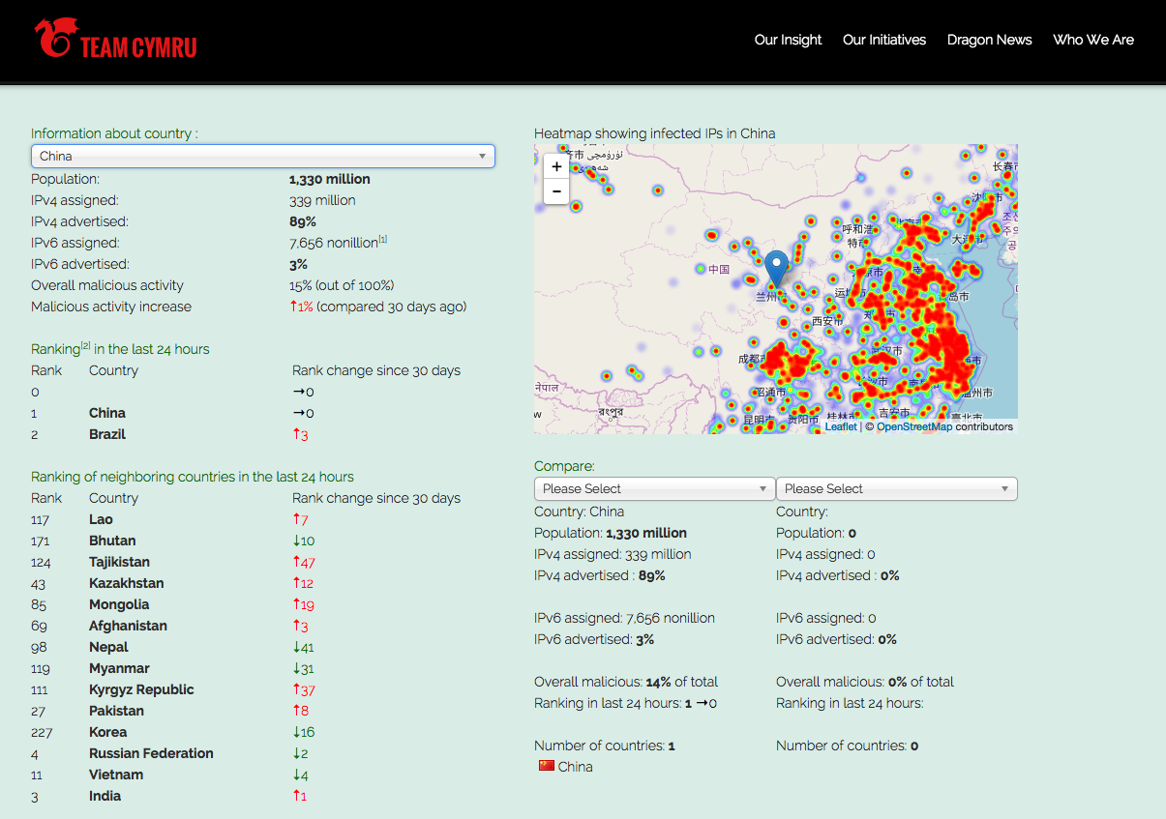

Team Crymru

## Resources

* [Botherder's list of reports detailing digital attacks on Civil Society](https://github.com/botherder/targetedthreats/wiki/Reports)
* [Citizen Lab](https://citizenlab.ca)
* [Open Observatory of Network Interference](https://ooni.torproject.org/)
* [OpenNet Initiative](https://opennet.net/)
* ["Fredom on the Net" Annual Reports by Freedom House](https://freedomhouse.org/report-types/freedom-net)
* [SAFETAG Full Guide: "Risk Assessment and Analysis," Page 10](https://safetag.org)
* [SAFETAG Full Guide: "Context Research," Page 27](https://safetag.org) # Privacy, Data Protection and Responsible Data

### Introduction

The objective of this module is to introduce champions to the key concepts they need to be familiar with in other to safely manage privacy issues and ensure the sensitive data they hold on individuals meets basic legal requirements and ethical requirements.

### Learning Goals

* Understand privacy and data protection policies - including country, industry and best practice
* Look at how third part and/or cloud provider policies can effect their security

### Assessment Goals

* Know which policies effect the work of the organisation
* Highlight areas the organisation must address to be able to meet privacy and data protection standards

### Recommend Preparations

Print off privacy and/or relevant data protection policies for a variety of organistions, so that participants can investigate them during the training. Where possible this should also include the any that are used by the organisations that the participants represent, so that any missing features can be easily identified.

### Suggested Time

45 Minutes

### Notes

Data protection regualation varies greatly from country to country. Where possible, you should customise this module based on the laws that champions operate in. We have chosen to base the legal aspects of this module primarily on EU law, as it is one of the strongest global frameworks and it's likely to be mirrored in many jurisdications.

## Activity

Break the participants into groups and ask them to examine and critically analyse the privacy and data protection policies from a variety of groups, for example Google, Facebook, the UN, their own organistions etc. Ask them to feedback on:

* How easy it is or isn't to read the policies
* What each policy allows the organisation to do or not to do with it
* What they think needs to be added to make them feel more comfortable using the service or organisation

## Discussion

* What does privacy mean to the participants?
* What data do they collect in their organisations?
* What expectations do they have of people who manage their data? (Give examples such as a their doctor, their bank, the government Google, Facebook etc.)
* Do they or their organisations meet these expectations for others?
* What relevant laws on data protection and privacy do they have in their country?
* Do they know of any examples of their organisation or similar organisations breaching data protection?
* What are the privacy and data protection policies of the providers they work with?

## Inputs

***Who's has your back?***  
The Electronic Frontier Foundation has developed a simple scorecard of how many (primarily US based) companies are deals with the legal aspects of user privacy.

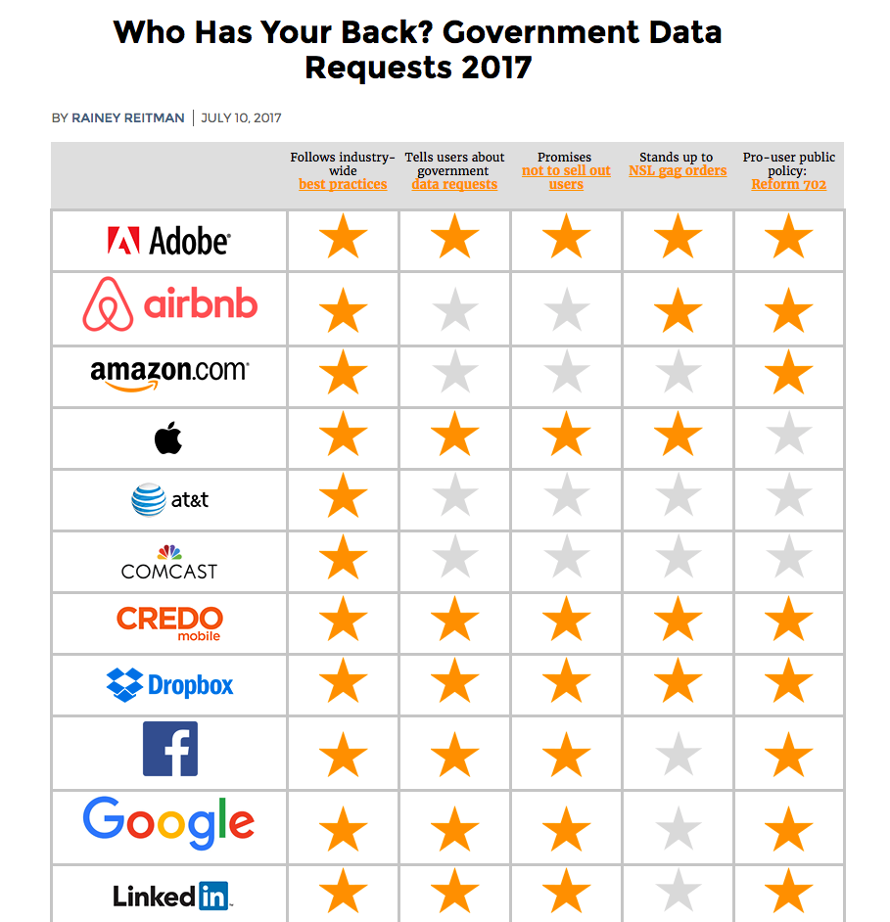 Source: [EFF "Who has your back?"](https://www.eff.org/who-has-your-back-2017)

***General Data Protection Regulation***  
There are many different privacy and data protection rules that apply to the data that you store and hold.

Because it is one of the most impacting and comprehensive, we are going to use the framework on the European Union General Data Protection Regulation.

It create's two disctinct roles and sets of responsibilities.

Data Controller: is the is the individual or entity who controls and is responsible for the for the collection and keeping of personal data. (For example, your organisation is they collect information on donors or individuals at risk.)

Data Processor: is the individual or entity who holds or processes the data but does not exercise responsibility or control over the personal data.

Many nonprofits are likely to be effected by it. Large fines for data protection failures have already been given out in the past and these are due to get bigger.

It has strong features such as:

* It's scope is very wide and includes all EU citizen data and data held by companies in the EU and/or with special arrangement outside of it
* Individuals or "data subjects" have a lot of rights including the right to be forgotten, portability, correction and to not be subject to adverse decisions caused by automated processing.
* Data protection fines can now be up to €20 million Euro or 4% of turn-over, whichever is higher
* Organisations must be clearer about why, how, where they store data and for how long
* Organisations must clearly explain their data protection policies when seeking consent. It cannot be hidden in legal jargon as part of terms and conditions.
* If collecting "sensitive" data that can identify or adversly affect an individual, they must take makes to ensure it's protection.
* Examples of protection include encryption or making the data pseudonymous or anonymous
* Data cannot be used for purposes other than the reasons that an individual agreed it to be collected for. With the exception of statistics, legal or public health purposes.

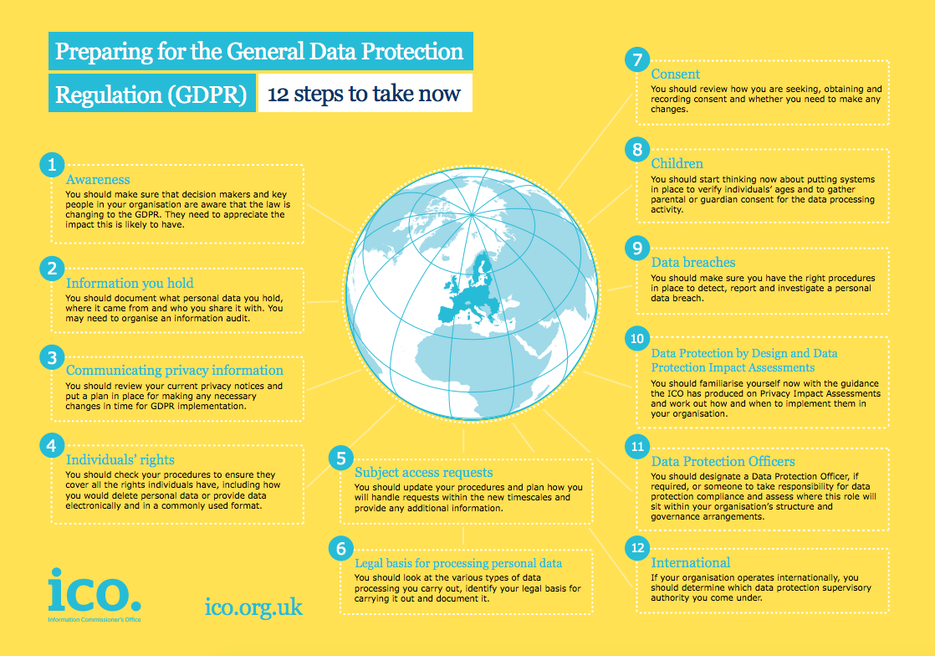 Source: [UK Information Commissioner Office](https://ico.org.uk/)

***Responsible Data***  
A number of civil society groups have been jointly working to share lessons and best practices for gathering and using data. This is known as the "Responsible Data" Project.

The group has defined that the responible use of data is *"The duty to ensure people’s rights to consent, privacy security and ownership around the information processes of collection, analysis, storage, presentation and reuse of data, while respecting the values of transparency and openness.”*

The project has created a handbook designed specifically for helping civil society groups develop, manage and close projects that hold sensitive information. It covers everything from survey choice to selecting hosting providers.

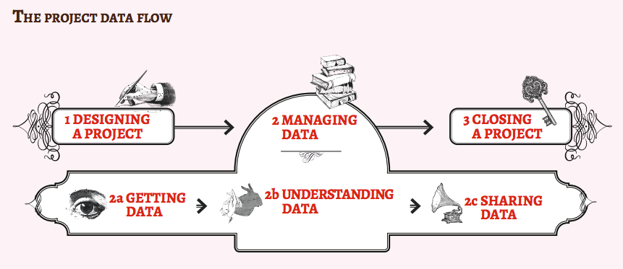 Source: [The Responsible Data Handbook](https://responsibledata.io)

## Deepening

Based on the outline of the GDPR, or other relevant legislation, along with the principals of Responsible Data. Split the participants into groups and give them a task to design a project taking into consideration all of these aspects. Example projects might include topics such as:

* The setup of a new fundraising database which holds lots of information about potential new donors
* A hostedd database that aims to record testimony and incident reports from victims of topic likely to contain sensitive data about a topic such as domestic and sexual assault
* A new system in your organisation for managing recruitment, payroll, disciplinary action, social security information - all of which is stored with a third party in their cloud

## Synthesis

Participants should turn to their assessment documentation and consider how their organisation deals with the subject matter covered in this module. Where necessary they should ask questions and work with other participants to identify any:

* Issues they have found that effect their organisations
* Possible solutions they have learned
* Possible difficulties they may face in implementation (ideally using the time ad experience of trainers and other participants)
* Things would need to overcome these difficulties
* Connections to other organisations or individuals that would help them
* Timeline, resources and costs for implementation

This should be noted in their assessment, for future use.

In line with keeping this curriculum as an updated community tool, we would also ask that participants provide comments, feedback and new ideas for this module on the project website and/or Github!

## Resources

* [Responsible Data Handbook](https://responsibledata.io/resources/handbook/)
* [Facebook Privacy Policy](https://www.facebook.com/policy.php)
* [Google Privacy Policy](https://www.google.com/policies/privacy/)
* [Twitter Privacy Policy](https://twitter.com/privacy)
* [United Nations Privacy Policy](http://www.un.org/en/sections/about-website/privacy-notice/)
* [The Guardian Privacy Policy](https://www.theguardian.com/info/privacy)
* [Open Whisper Systems Privacy Policy](https://whispersystems.org/signal/privacy/)
* [Tor Project Privacy Policy](https://donate.torproject.org/privacy-policy.html)
* [Comparing the privacy policy of internet giants side-by-side](https://www.comparitech.com/blog/vpn-privacy/we-compared-the-privacy-policies-of-internet-giants-side-by-side/)
* [DLA Piper - Data Protection Laws of the World](https://www.dlapiperdataprotection.com)
* [European Union - General Data Protection Regulation](http://www.eugdpr.org)
* [Privacy Policy Generators](https://digital.com/blog/best-privacy-policy-generators/)
* [Guide for System Administrators in At‐Risk Organizations: Ensuring User Data Protection and Privacy](https://github.com/mahvashtaqi/System_Administrator_Guide_Text/blob/master/en/best_practices/ensuring_user_data_protection_and_privacy/index.md) # User Education

### Introduction

Many champions will have already have previous experience training individuals in their own organisations. This module and course is not designed to train trainers (there are many resources such as [Level-Up](https://www.level-up.cc) that already do this well), instead it is an opportunity to explore some of the tools that are available and to share best practices for integrating user education into organisaions.

### Learning Goals

* Help participants learn about current initiatives for peer education and training
* Participants share and critique various resources for peer education and training
* Participants share experiences and best practices on peer education

### Assessment Goals

* Develop measures and plans to integrate user education and training into work of their organisations

### Recommend Preparations

N/A

### Suggested Time

30 mins

### Notes

## Activity

N/A

Trainer Note: While this course is not a training of trainer course, it might become relevant for participants to use this opportunity to test and benchmark their own user education efforts. If so, one activity that could be useful is asking participants to prepare a short five/ten minute presentation and deliver it to the group. The group would then be asked to provide feedback on delivery, message and feedback - as if they were people recieving the training within the individuals organisation for the first time.

## Discussion

Using a flip-chart or other medium, break up participants into groups and ask them to answer and document questions such as the following:

* Why do we do user education?
* What are our own experiences of delivering user education?
* What topics do we cover?
* How do we deliver user education?
* What tools and resources do we use for user education? Why? Which tools are the most useful? Which does are the most up-to-date?
* What tools and resources do we not currently have that would help us in user education?
* How long do we take to deliver user education?
* What have been our positive / negative experiences when delivering user education?
* How do we measure success or failure in user education?
* What methods help us increase success in user education?
* How do we measure success or failure in implementation?

## Inputs

N/A

There are a number of tools available for validating user education initiatives.

For example:

* Testing understanding and implementation of advice on phishing

There are also a number of tools available for measuring progress in user education courses. A number of these can be self hosted.

## Deepening

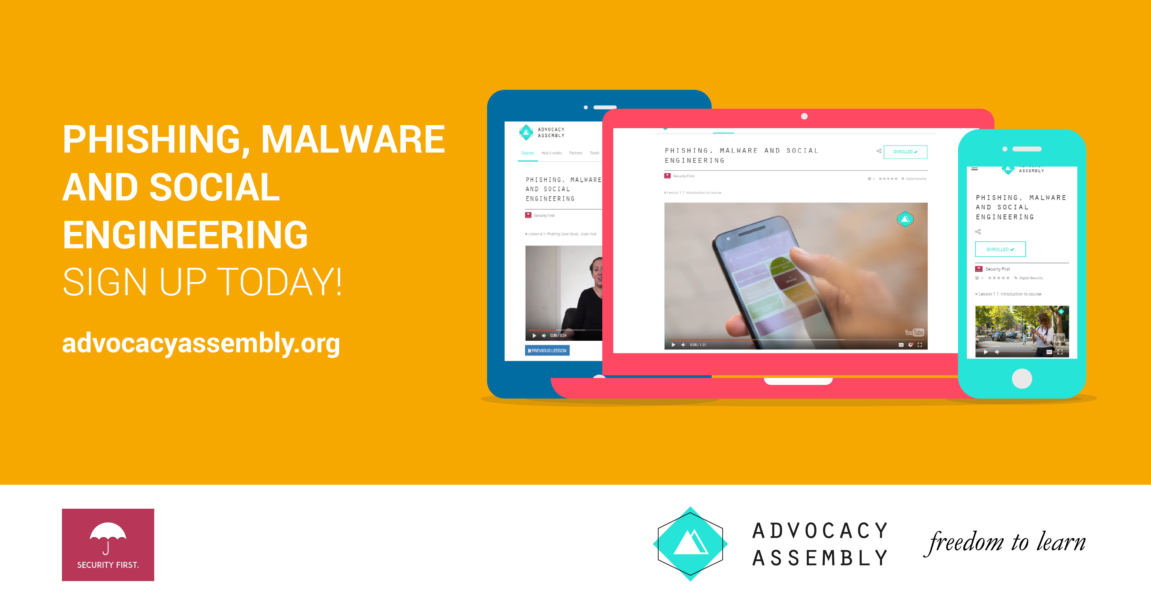    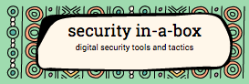 

## Synthesis

Participants should turn to their assessment documentation and consider how their organisation deals with the subject matter covered in this module. Where necessary they should ask questions and work with other participants to identify any:

* Issues they have found that effect their organisations
* Possible solutions they have learned
* Possible difficulties they may face in implementation (ideally using the time ad experience of trainers and other participants)
* Things would need to overcome these difficulties
* Connections to other organisations or individuals that would help them
* Timeline, resources and costs for implementation

This should be noted in their assessment, for future use.

In line with keeping this curriculum as an updated community tool, we would also ask that participants provide comments, feedback and new ideas for this module on the project website and/or Github!

## Resources

* [Level-Up](https://level-up.cc/)
* [My Shadow](https://myshadow.org/)
* [NIST: National Initiative for Cybersecurity Education](http://nvlpubs.nist.gov/nistpubs/SpecialPublications/NIST.SP.800-181.pdf)
* [Guide for System Administrators in At‐Risk Organizations: Physical Security](https://github.com/OpenInternet/System_Administrator_Guide_Text/blob/master/en/best_practices/staff_awareness_and_communications/index.md)
* Digital Security Diagnostics for Civil Society Organizations: A guide for facilitators

# Password Management

### Introduction

Despite their many problems, passwords continue to be the most common security feature of everything from phones to encrypted cloud storage. As computing power increases and attacks become more widespread, it becomes harder and harder for individuals to create use and store passwords in secure, efficent way. Organisations must also deal with the need to share passwords internally. Password managers offer some help but there are many available and each has different strengths and weaknesses. Other tools like two-factor and tokens are also increasingly common. This module looks at some methods of managing passwords within organisations.

### Learning Goals

* Map the usage of passwords throughout an organisation
* Understand the tools available for password management throughout an organisation
* Understand the settings of various tools (e.g. network management) that enforce password policy
* Discuss and test external keys such as YubiKey

### Assessment Goals

* Add the organisation's recommended tool for password management - including resources useful for teaching. Even if the tool is individual (e.g. KeepassXC) vs. centrally managed
* Identify any services that allow for two factor authentication that are not already enabled

### Recommend Preparations

N/A

### Suggested Time

60 Minutes

### Notes

N/A

## Activity

* Ask participants to list the variety of passwords and services used by them and their organisations in their work.
* For each of the services, mark if they have two factor authentication enabled.
* For each service, also mark if SMS or app generated code is available.
* Ask participants to test estimate the size of the average password that they or the people in their organisations use and test it (e.g. on https://password.kaspersky.com)
* Ask participants to test their email accounts and see if they have been affected any of the main breaches (e.g. https://haveibeenpwned.com/)

## Discussion

* What tools do the participants use for password management?
* What are the advantages and disadvantages of each tool?
* What recent cases studies of password managers being breached do we know about? How did they occur?
* Which of these tools can be deployed and managed across organisations?
* How do these tools integrate in a mobile environment?
* What experiences do participants have in managing passwords across organisations? What are the advantages/disadvantages?

## Inputs

***SMS Two Factor***  
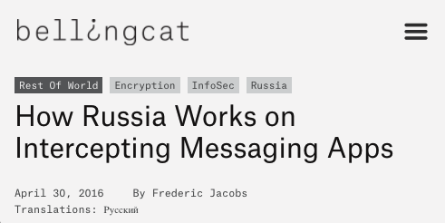

In a number of examples, SMS's used by the services as a second factor of authentication have been intercepted, thus where possible, it should not be used - an app or key should be used instead. (e.g. https://www.bellingcat.com/news/2016/04/30/Russia-telegram-hack/)

***Shared Password Management for Organisations*** A number of services offer shared password management for organisations. Break participants into groups and ask them to test some of them and report back on their advantages and disadvantages. If they already use or have tested a specific service, they should be in a group where they are testing tools they have not used before.

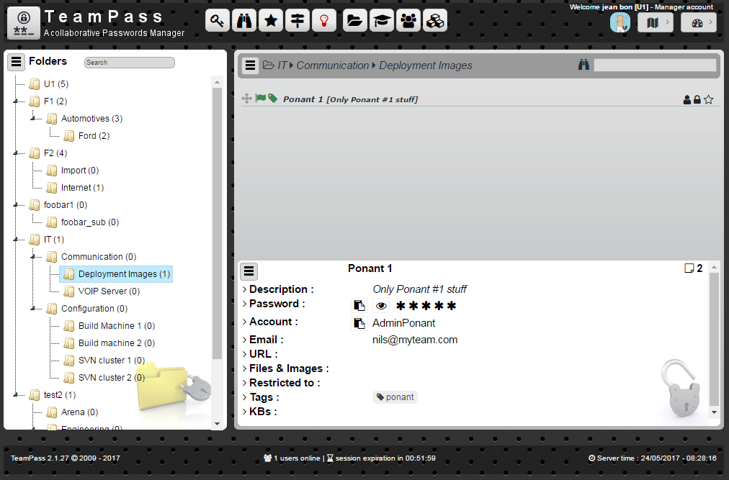

Teampass

Some possible tools:

* KeepassXC (on a shared drive) - https://keepassxc.org
* Passbolt: https://www.passbolt.com
* Teampass: http://teampass.net
* Lastpass (it has a non-profit discount): https://lastpass.com
* Dashlane: https://www.dashlane.com

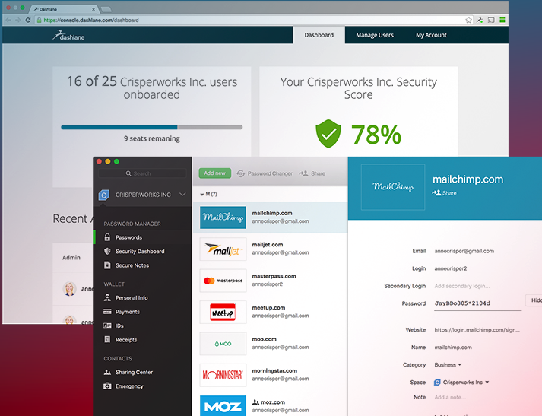

Dashlane

***Monitor Domain Breaches***

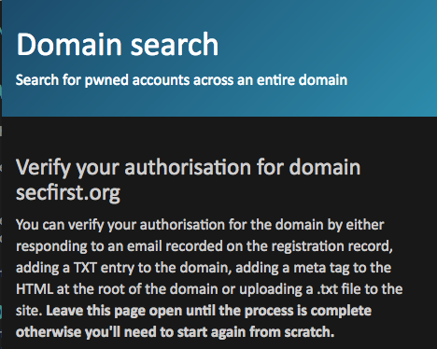  
*Haveibeenpwned.com has a useful and simple feature for managing breaches across a whole domain*

## Deepening

***Best practices for managing passwords in organisations***  
Current best practices for managing passwords within an organisation that it is recommended a champion understand include:

* Change all default passwords
* Implement two factor were possible
* Help users cope with password overload
* Understand the limitations of user generated passwords
* Understand the advantages and limitations of machine generated passwords (e.g those that create phrases for users to remember)
* Prioritise the security of administrator and remote user accounts
* Use account lockout, passwords blacklists, IP blocking (for remote accounts) and protective monitoring
* Don’t store passwords as plain text

For many years, best practice advice recommended that users were told or forced to change their passwords frequently - typically every 30/60/90 days. However, recently many have questioned this advice - as often it just leads to user frustration, difficulty to remember passwords, password reuse or creation weaknesses (e.g changing from an old password "redpanda1" to "redpanda2"). Instead a focus is now recommended on monitoring logins for unsuccessful attempts and allowing users to use tools such as password managers and and hardware tokens.

***Utilise exisiting administation tools***  
Many organisations with central password control use Microsoft or Google's G-Suite to manage their infrastructure.

* Microsoft Office 365: https://support.office.com/en-us/article/Office-365-for-business-%E2%80%93-Admin-help-17d3ff3f-3601-466e-b5a1-482b31cfb791
* G-Suite: https://support.google.com/a/answer/3035631?hl=en&ref_topic=3113051

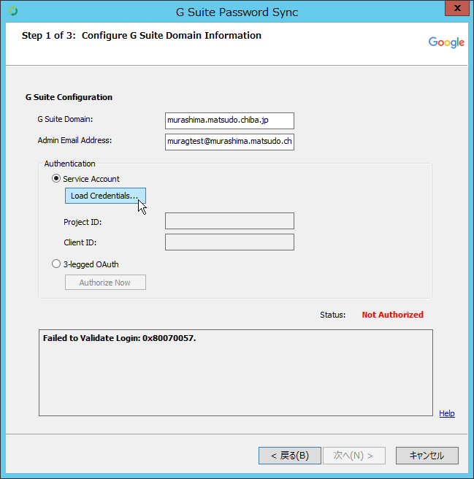

Gsuite Password

Use of hardware key/token. A useful alternative method of securing access is the usage of a hardware token such as a YubiKey. If possible, we recommend that a trainer introduces a hardware token to participants and demonstrates setting it up with a service such as Gmail (https://support.google.com/accounts/answer/6103534?hl=en) or Facebook.

* Where possible it is best to recommend keys that are part of the FIDO ("Fast IDentity Online") Alliance - as these are the most commonly accepted and integrate best with online services.

Examples of popular keys include:

* YubiKey - https://www.yubico.com
* Trezor - https://trezor.io
* Nitrokey - https://www.nitrokey.com
* RSA SecureID - https://www.rsa.com

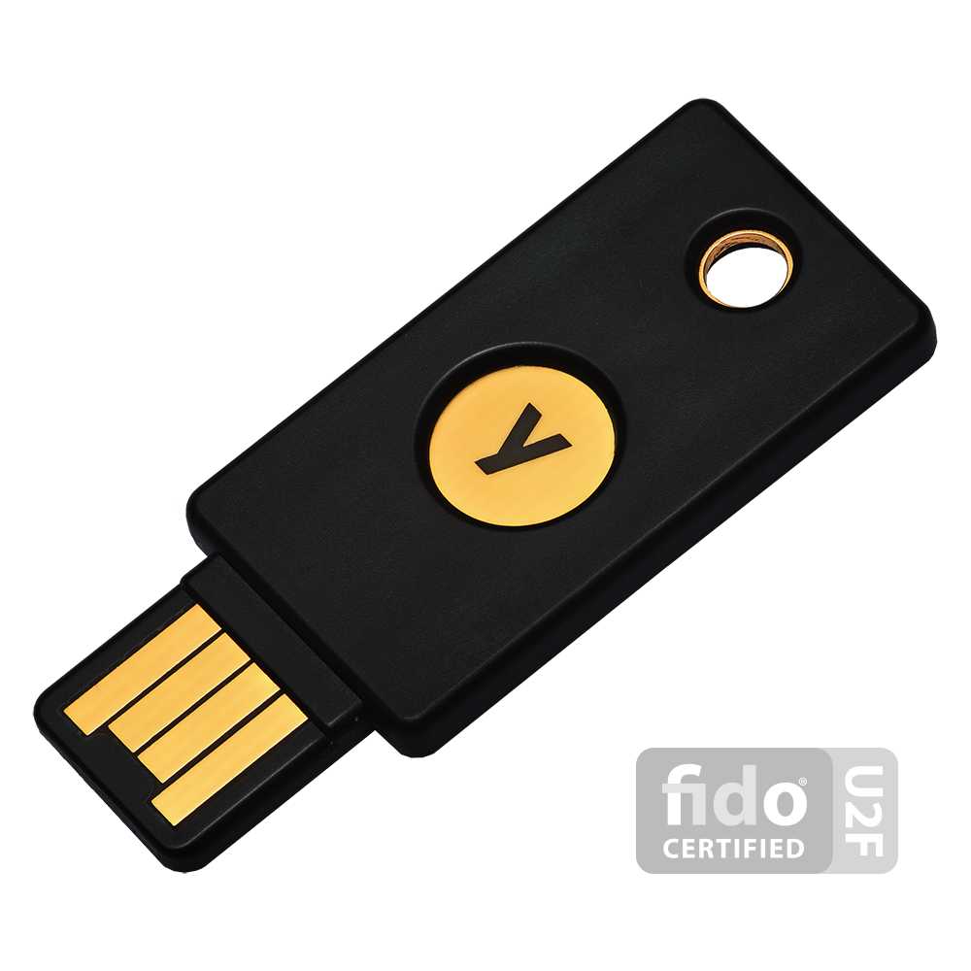

Yubikey

A number of keys also have specific storage features such as storing SSH keys, certificates, etc.

It should be noted that hardware tokens come with a number of problems. Such as cost, setup difficulty and procedures for if they are lost and/or damaged. Ask participants how they feel they may be able to deal with these problems.

***Interactive Online Training***  
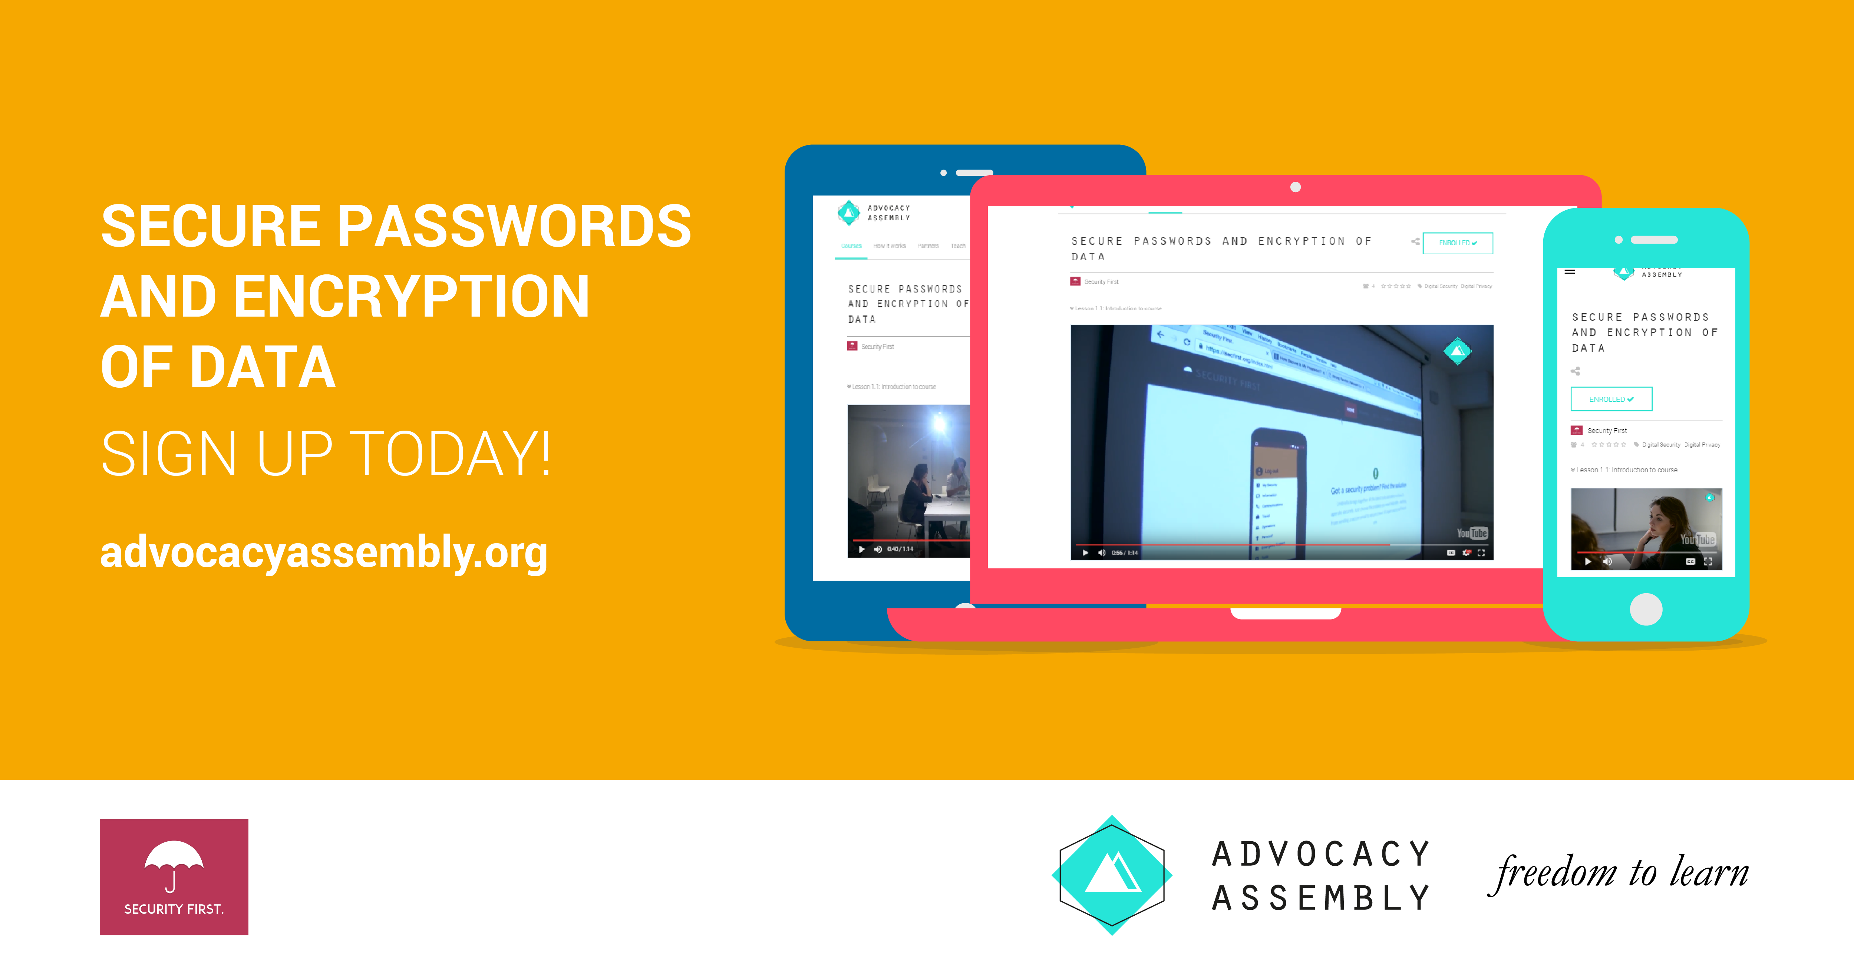 For champions working with individuals remotely or who do not have the time to be able to train others in person. A free online short (20 minute) course with video and quizzes on passwords designed by [Security First](https://wwww.secfirst.org) is available in English, Arabic and Farsi for free on [Advocacy Assembly](https://advocacyassembly.org).

## Synthesis

Participants should turn to their assessment documentation and consider how their organisation deals with the subject matter covered in this module. Where necessary they should ask questions and work with other participants to identify any:

* Issues they have found that effect their organisations
* Possible solutions they have learned
* Possible difficulties they may face in implementation (ideally using the time ad experience of trainers and other participants)
* Things would need to overcome these difficulties
* Connections to other organisations or individuals that would help them
* Timeline, resources and costs for implementation

This should be noted in their assessment, for future use.

In line with keeping this curriculum as an updated community tool, we would also ask that participants provide comments, feedback and new ideas for this module on the project website and/or Github!

## Resources

* [Security In a Box - Create and Maintain Secure Passwords](https://securityinabox.org/en/guide/passwords/)
* [EFF Suveillance Self Defence - Creating Strong Passwords](https://ssd.eff.org/en/module/creating-strong-passwords)
* [Umbrella App - Passwords](https://www.secfirst.org)
* [Centre for the Protection of National Infrastructure](https://www.cyberstrategies.co.uk/admin/resources/passwordguidance-simplifyingyourapproach.pdf)
* [Information Ecology - Authentication Checklist](https://0xacab.org/iecology/security-checklists/blob/master/5_authentication_checklist.md)

# Web and Email Management

### Introduction

All organisations use email in some form and most have an online presence. This moudule introduces some of the management features for popular email tools and also recommends a number of methods for mitigating website hosting risks.

### Learning Goals

Learning Goals:

* Understand the advantages and disadvantages of web providers and hosts (including analysis of specific companies)
* Understand the advantages and disadvantages of self hosting vs. cloud
* Test and assess the feature sets of G-Apps Suite, Office365 and Exchange and/or other systems for management.
* Test and assess the security features of web hosting platforms such as Wordpress, introduce LetsEncrypt
* Understand services providing free DDoS protection for HRDs
* Assess the security and usage of "privacy friendly services such as Protonmail and Tutanota
* Assess the advantages/disadvantages of PGP tools and implementations and management of keys

### Assessment Goals

* Add any necessary changes to security and privacy features of their organisations email service
* Add any necessary changes to their organisation's web hosting service (e.g. Wordpress)
* Add DDoS protection service (if needed)

### Recommend Preparations

Where possible, it would be best for the trainer to have acces to trial or demo versions of the tools that are likely to be used in the module. Ideally participants will be able to then login and test them for themselves - without causing disruption to live systems. For example, G-Apps Suite, Protonmail, Wordpress etc.

### Suggested Time

60 Minutes

### Notes

N/A

## Activity

Ask participants to draw a map of the web and email services they and their organisation use for work.

Get them to describe details such as costs, advantages, disadvantages, features, privacy, maintenance effort etc.

## Discussion

* What operations or security issues have participants experienced in their work when using web services or email?
* What are the advantages and disadvantages of cloud vs. self hosted tools?
* What capabilities do you need to securely manage self-hosted tools?

For those who have implementated PGP within their own organisations.

* How have did they do it?
* Is it an individual responsibility? (E.g each user creates and manages their own PGP mail, shares keys)
* Is it managed centrally? (e.g using a tool such as Symantec Key Management Server)
* What other methods have individuals found to management PGP deployment?

## Inputs

A number of privacy focused email services have emerged that aim to make encryption easier. In particular ProtonMail and Tutanota. Setup an account with both and show the features of each. Ask the participants, what they think the advantages and disadvantages of such services are. For example easy of use versus vendor lock-in.

Show the security features and management of: Gmail, G-Suite, Microsoft 365 and Microsoft Exchange.

* Show how to set-up a Certbot Certificate
* Show Cloudron and Sandcats, Mailpile
* Emphasis that Docker can also provide some of the functionality but requires more maintenance and setup

Ask participants, would they consider using a tool such as Cloudron? Why?

A hosting provider with free hosting for civil society groups is called Eclips.is https://eclips.is/

## Deepening

***Securing Regualar Email***

*G-Mail*  
Many organisations rely on Google for their email. Either by integrating it into the personal email accounts of their staff or by using managing it with Google Suite. Champions are already likely to know about the security features of personal G-Mail but if not it can do things such as:

* Two Factor Authentication
* List Recently Used Devices
* List Last Account Activity
* Manage apps with access to the Google Account
* Use hardware tokens such as a YubiKey
* For some attacks, it may notify individuals if they have possibly been the vitim of "government-backed attackers"

Where organisations are reliant on using personal G-Mail for communications. It is recommended that a champion would help individuals conduct a training and/or a review of all of their email settings, to enhance security.



Google Suite

*G-Suite* Using Google G-Suite to manage email within an organisation also offers a number of additional security features. For example:

* Easily add and remove users
* Reset passwords
* Use a Single Sign-on (SSO)
* Add or force users to users to use two-step verification
* Manage security settings on user devices
* Lock and remote wipe user devices
* Malicious link and file scanning
* Get alerts about suspicious activity across the organisation
* View audit logs



Office 365

*Office 365* Office 365 administration offers a number of security features in it's administrator settings, such as:

* Easily add and remove users
* Reset passwords (both individual and in bulk)
* Set password expiration policy
* Create with different permissions (staff, administators etc)
* Control sharing of documents internally and externally (including options for anonymously)
* Options to extend it with email malicious link and attachment scanning
* Suport for two factor authentication
* Mobile Device Management features
* Integrate with Azure Active Directory
* Can choose which region to store your data
* Templates for Data Loss Prevention (e.g scanning for specific senstive information and blocking it from leaving the organisation)

 

***Encypted Email Services***  
A number of services have become popular that provide attempt to make it easier for individuals to use encrypted email. Examples of them include [Protonmail](https://www.protonmail.com) and [Tutanota](https://www.tutanota.com). Choice of secure email service can often be tricky. Champions often find themselves asked questions about which services are best to use. [That One Privacy Site](https://thatoneprivacysite.net) has been created to make it easier to compare features such as privacy, cost, and logging.

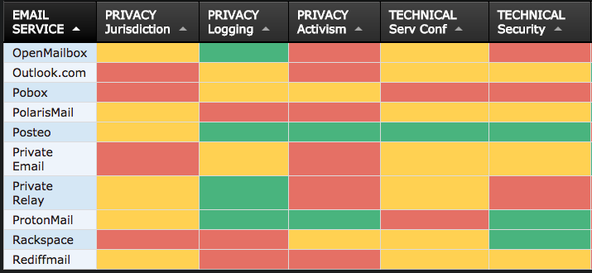 *Example of the comparison on "That One Privacy Site"*

Some advantages of these:

* Ease of setup and use
* Free tiers for individuals
* Good mobile apps
* Can be whitelabelled / used with organisation's domain
* Less associated with activism then well known services such as Hushmail or Riseup
* Ability to send an encrypted mail to an individual not on the service (Tutanota allows a plaintext email to be sent with a link to a password protected email - the password must be sent through another channel)

Disadvantages

* They are closed, proprietry systems. Only mail between account holders is encrypted. Users must trust the company.
* No integration with PGP
* Don't integrate with third party tools such as Outlook, Thunderbird, Mail, K-9 Mail etc
* Not possible to export email to other services
* No verification of email addresses (easy to send a unencrypted email to a non service account

Virtu is another secure mail service that provides integrates into existing Google or Microsoft email products. It's encryption is also proprietry.

***Managing Secure Email***  
PGP - Individual Most Champions will already have experience using PGP for individuals - e.g Gpg4win with Outlook, Enigmail with Thunderbird, GPG Tools with Apple Mail, OpenKeychain with K-9 Mail, Mailvelope with Chrome/Firefox. There are many excellent resources available for that online.

PGP - Management There are very few tools available to manage PGP implementations across an organisation. Symantec offers a number of tools such as Desktop Mail Encryption and Gateway Email Encryption. This is probably the most commonly used tool for central management and deployed of PGP within an organisation, however it has a number of problems:

* It is expensive
* It can be complex to deploy
* It's mobile apps for viewing encrypted mails are of poor quality
* It only integates with Microsoft Exchange Server or IBM Domino

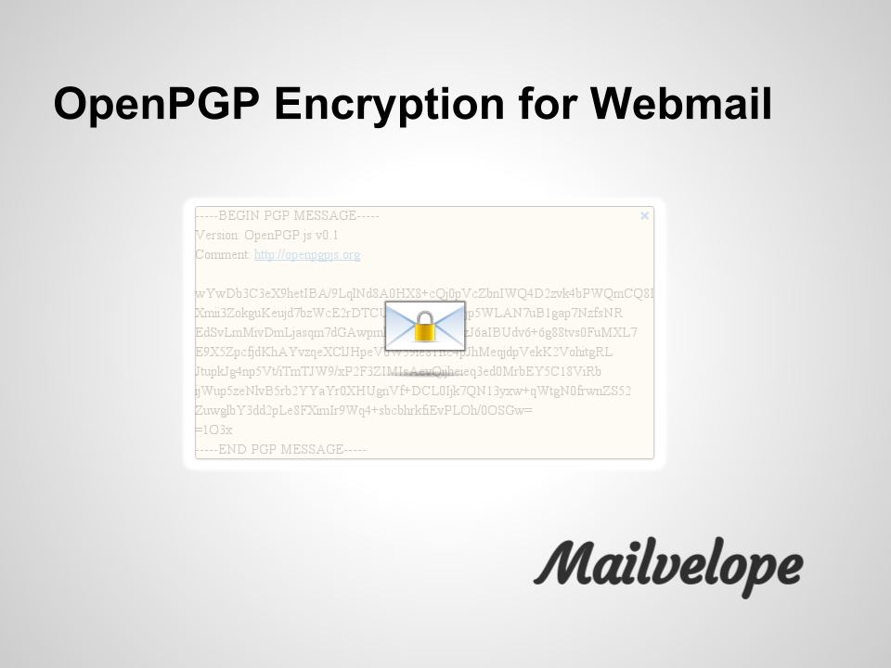

Mailevelope

There are a number of open source tools that attempt to make key exchange within organisations easier, including [Mailvelope Key Server](https://keys.mailvelope.com) and [Hockeypuck](https://hockeypuck.github.io).

***Avoiding Abuse and Spam Lists***

Civil society groups are often targets for email abuse. Often this can lead to the spread of spam from an organisations domain which can lead to emails being blocked. To prevent this, an organisation should setup a Sender Policy Framework (SPF) and DomainKeys Identified Mail (DKIM).

* A SPF record allows the recieving server of a mail to check that it orginated from the an authorised host.
* A DKIM adds a digital signature to outgoing emails to verify that the message comes from your domain and has not be manipulated enroute.

Most email providers allow you to setup both of these services. For G-Suite you can find out how to setup [SPF](https://support.google.com/a/answer/178723?hl=en) and [DKIM](https://support.google.com/a/answer/174124?hl=en).

If sending mail to a large amount of people (for example a newsletter), it is better to either send from a different domain/subdomain (e.g securityletter.com instead of security.com). Alternatively, using a services such as [Mailchimp](https://mailchimp.com/) or [GetResponse](https://www.getresponse.com/).

***Managing Websites***



Wordpress

*Wordpress*  
Wordpress is a very common platform for organisations to host their websites. In 2016, 60% of websites using a Content Management System used it (Joomla was 7% and Drupal 5%). Because of it's popularity, it is regularly targetted for attack.

Basic methods of increasing the security of Wordpress include:

* Use a strong password and two factor authentication to login
* Limit access and minimise permissions for folders, users and admins
* Change the default admin name
* Update regularly (weekly or monthly at a minimum)
* Only install and use extra plugins that you really need
* Do not install pirated themes or plugins
* Keep backups
* Hide the login area
* Lock-out or delay users after a number of attempts to avoid bruteforcing
* If using a security plugin such as Wordfence Security, it is best not to run another similar plugin, as they can often cause problems when run together
* Run a reputable anti-malware scanner
* Check logs for intrusion attempts

For more ways to harden Wordpress deployments, see: [Hardening Wordpress](https://codex.wordpress.org/Hardening_WordPress)

*Website Security*  
All websites and web applications can potentially be at risk from a variety of possible attack methods. While there are many ways to setup and run a web site or application securely, there are ten top mitigations that are recommended for best practice.

[OWASP Top 10 Cheat Sheet for Web Security](https://www.owasp.org/index.php/OWASP_Top_Ten_Cheat_Sheet)

*Distributed Denial of Service (DDoS)*  
 Many civil society groups are the targets of DDoS attacks both randomly and targeted because of their work. Such attacks can damage services, drive up hosting costs and block the websites from operating. A number of services exist that protect from DDoS and are free to civil society groups. For example:

* Deflect - https://deflect.ca
* Google Project Shield - https://projectshield.withgoogle.com/

*Making your website available over Tor*  
In a number of countries, temporary or full blocking and censorship of websites can often occur. Also, visiting your website might attract suspicion. To make a copy of your own website available as a .onion site over Tor, there is now a tool that makes that a lot easier, called the Enterprise Onion Toolkit https://github.com/alecmuffett/eotk

## Synthesis

Participants should turn to their assessment documentation and consider how their organisation deals with the subject matter covered in this module. Where necessary they should ask questions and work with other participants to identify any:

* Issues they have found that effect their organisations
* Possible solutions they have learned
* Possible difficulties they may face in implementation (ideally using the time ad experience of trainers and other participants)
* Things would need to overcome these difficulties
* Connections to other organisations or individuals that would help them
* Timeline, resources and costs for implementation

This should be noted in their assessment, for future use.

In line with keeping this curriculum as an updated community tool, we would also ask that participants provide comments, feedback and new ideas for this module on the project website and/or Github!

## Resources

* [Information Ecology: Email Safety Checklist](https://0xacab.org/iecology/security-checklists/blob/master/4_email_safety_checklist.md)
* [Guide for System Administrators in At‐Risk Organizations: Website, Software and System Security](https://github.com/OpenInternet/System_Administrator_Guide_Text/blob/master/en/best_practices/website_software_and_system_security/index.md) # Mobile Device Management / Bring Your Own Device

### Introduction

Mobile devices are now an essential part of our work and personal life. Individuals generally expect to be able to use thier own chosen devices. This is often good as it raises productivity, allows flexibility and reduces the organisations costs for purchasing equipment.

However managing mobiel devices securely is complex. They have as much, if not more data about us than our computers do, however they are even more vulerable. They can be lost, stolen, effected by malware and many of them (especially Android) lack security precautions such as regular updates.

This module aims to introduce some simple tools and methdologies for managing mobile devices in an oranisation.

### Learning Goals

* Understand positives/negatives of MDM / BOYD policies
* Exam some common options for simple MDM within an organisation

### Assessment Goals

* Add template for MDM/BYOD in their organisation
* Have identified and tested a solution for MDM/BYOD if relevant to their organisation### Recommend Preparations

### Recommend Preparations

Print off copies of example BYOD/MDM policies.

It is recommended that the trainer have already prior experience setting up at least one or two of the MDM/BYOD tools. Where possible it makes sense to have training account that can be used during the module.

### Suggested Time

30 Minutes

### Notes

N/A

## Activity

N/A

## Discussion

* What devices are used within the participants organisations?
* What devices are within the room?
* What are the dangers of having multiple types of devices with access to sensitive information in an organisation? (e.g. lack of encryption, poor Android update infrastructure, hard to manage)
* What have been the participants problems with managing multiple devices in their organisation?
* What systems, if any have been used?
* What have been the advantages and disadvantages of the tools used?

## Inputs

***Policies***

MDM or BYOD comprises of both internal policies and technical solutions.

Provide participants with example templates of a MDM/BYOD policy and ask them to critique it within their own organisations. What would they use? What would they need to add in? How could it be implemented?

Example Templates include:

* https://cp.labtechsoftware.com/assets/marketing_materials/pdf/mobility_byod_policy.pdf
* http://www.code3pse.com/public/media/22845.pdf
* https://cdn2.hubspot.net/hub/445439/file-2042247754-pdf/images/Sample-BYOD-Policy-Template.pdf
* http://www.itmanagerdaily.com/byod-policy-template/
* http://www.webtorials.com/main/resource/papers/fiberlink/paper2/MDM_Policies_Best_Practices_Guide.pdf

***Android***  
While the variety of mobile devices available precludes spending much time discussing the merits of each. It is worth highlighting the risks caused by the fragmentation of the Andrid device ecosystems. A signficiant amount of Android devices do not recieved the lastest security updates and thus are very vulnerable to previously patched security holes. This is particularly problematic to individuals with older Android devices.

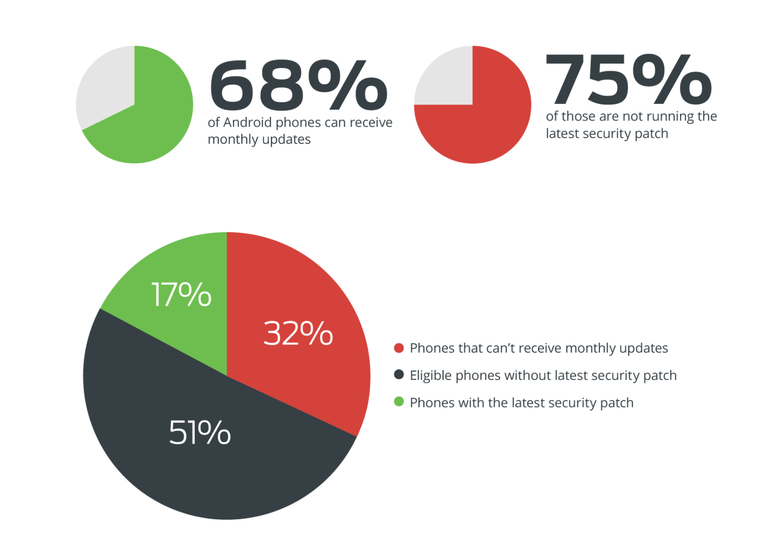 Source: [Thirty Percent of Android Devices Susceptible to 24 Critical Vulnerabilities](https://duo.com/blog/thirty-percent-of-android-devices-susceptible-to-24-critical-vulnerabilities)

For more information:

* [The State of Android Software Updates 2017](https://www.miradore.com/blog/the-state-of-android-software-updates-2017/)
* [Android Security Bulletin](https://source.android.com/security/bulletin/)

## Deepening

Test the usage of at least one of the MDM/BYOD services with the devices within the room.

* [Google G-Suite](https://www.google.com/non-profits/)
* [Microsoft Office 365] (https://support.office.com/en-i.e./article/Capabilities-of-built-in-Mobile-Device-Management-for-Office-365-a1da44e5-7475-4992-be91-9ccec25905b0)
* [Microsoft Intune](https://www.microsoft.com/en-ie/cloud-platform/microsoft-intune)
* [Prey - open source tool](https://www.preyproject.com)
* [Miradore - paid but has free and self hosted version] (https://www.miradore.com)
* [Packet Fence](https://packetfence.org)
* [VMWare Airwatch - has free trial](https://www.air-watch.com)

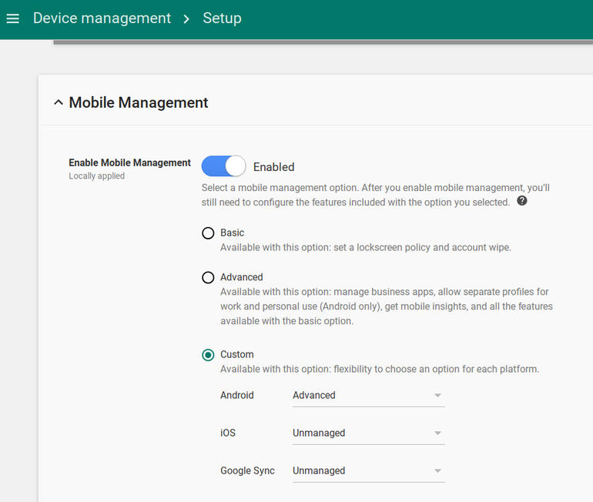

G-Suite MDM

*Example of the features in G-Suite*

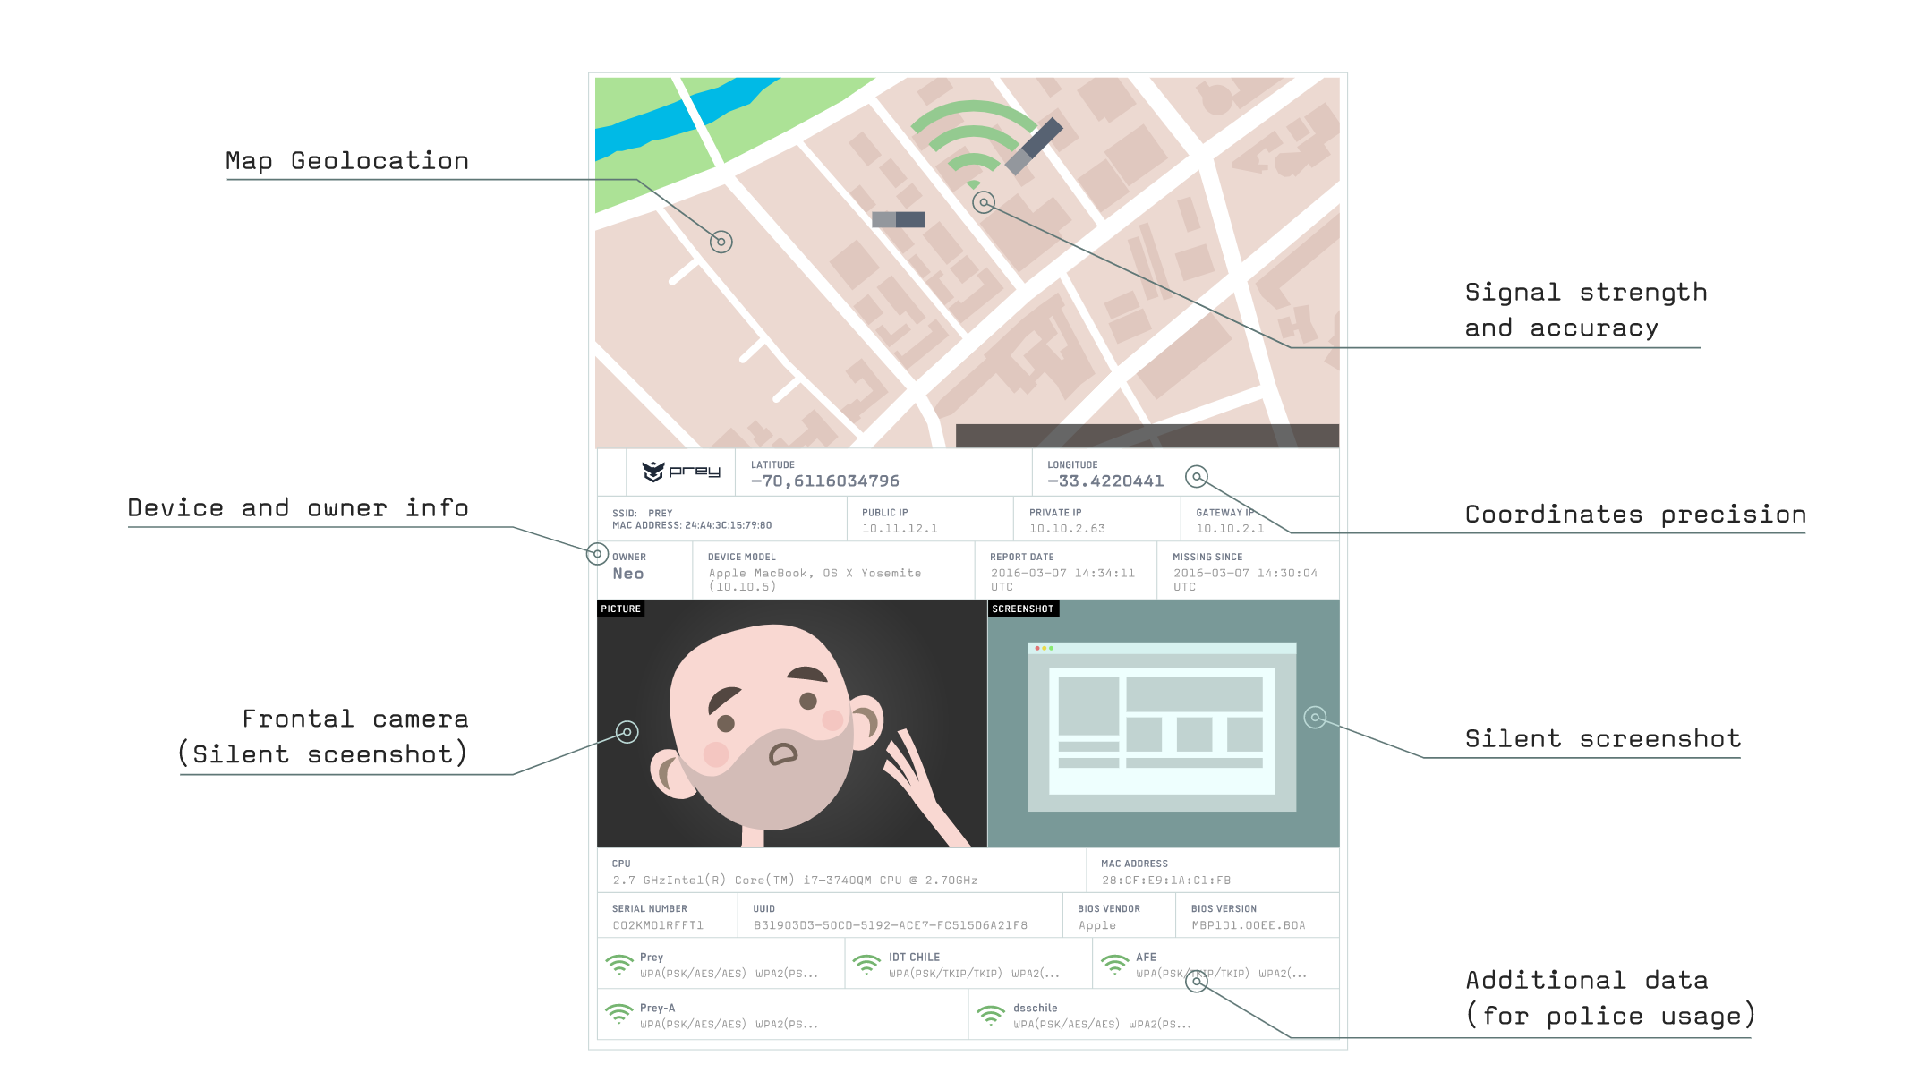 *Example of the features in Prey Project - an open source tool with some limited MDM/BYOD capability*

Ask participants to feedback on issues such as:

* Easiness of setup and deployment
* Features
* Security
* Cost
* Advantages and disadvantages

What other open source tools or those available at low cost from [Techsoup](http://www.techsoup.org) can be utilised?

## Synthesis

Participants should turn to their assessment documentation and consider how their organisation deals with the subject matter covered in this module. Where necessary they should ask questions and work with other participants to identify any:

* Issues they have found that effect their organisations
* Possible solutions they have learned
* Possible difficulties they may face in implementation (ideally using the time ad experience of trainers and other participants)
* Things would need to overcome these difficulties
* Connections to other organisations or individuals that would help them
* Timeline, resources and costs for implementation

This should be noted in their assessment, for future use.

In line with keeping this curriculum as an updated community tool, we would also ask that participants provide comments, feedback and new ideas for this module on the project website and/or Github!

## Resources

* [Microsoft: Set up Mobile Device Management (MDM) in Office 365](https://support.office.com/en-ie/article/Set-up-Mobile-Device-Management-MDM-in-Office-365-dd892318-bc44-4eb1-af00-9db5430be3cd)
* [NIST: "User’s Guide to Telework and Bring Your Own Device Security"](http://nvlpubs.nist.gov/nistpubs/SpecialPublications/NIST.SP.800-114r1.pdf)
* [UK National Cyber Security Centre: "End User Device Security Collection"](https://www.ncsc.gov.uk/guidance/end-user-device-security)
* [UK Government BYOD Guidance](https://www.gov.uk/government/publications/byod-guidance-executive-summary/byod-guidance-executive-summary) # Encryption, Patching, Licensing

### Introduction

The aim of this module is to help champions learn methods for managing some of the most important methods for mitigating their organisations risk with digital devices.

### Learning Goals

* Understand the need for and types of encryption available on devices
* Knowledge of the various systems for managing encryption, patching and licensing

### Assessment Goals

* Add the current status of encryption, patching and licensing across their organisation
* Established relationship if necessary with provider such as TechSoup who can provide discount
* Added rough costing of any new software or service to their development plan

### Recommend Preparations

N/A

### Suggested Time

45 mins

### Notes

N/A

## Activity

Ask participants to list the types of devices that they currently have on them. Usually this will result in a mix of devices: Android phones of various brands, different types of laptop, iOS devices, tablets etc. Divide participants into smaller groups with a mixture of devices within each group.

On a flipchart or with post-its, ask participants to list their devices.

Ask them list the device, then

* If they have full disk encryption turned on
* The current level of operating system and security update level and/or licence being used by it. For example, an old laptop may be running Windows XP and last had an update in 2014. A new iPhone may have had the latest version of iOS installed and an old Android phone may not have been receiving security updates.

Participants then search for known vulnerabilities in each of the devices listed using a website such as https://www.cvedetails.com or https://www.rapid7.com/db/modules/. Beside each operating system, if they find a vulnerability they should briefly describe what the vulnerability is.

If time allows, the same process can also be done for specifically common pieces of software, such as Chrome, Firefox, Java, Adobe or Microsoft Office.

Using data on most vulnerable software, ask participants to list which other pieces of software they or their organisation might be vulnerable to (for example: https://www.flexerasoftware.com/enterprise/resources/research/country-reports/)

## Discussion

Bring participants back into plenary session and ask them:

* What do they see as the benefits/disadvantages to full disk encryption?
* What has been their experiences when implementing it personally? Within their organisations?
* What way do they/their organisations manage patching and licensing in their organisations?
* What problems have they had with managing patching and licensing in their organisations? (e.g. scale, distribution, multiple systems, cost)
* What methods, systems or software have they used to manage patching and licensing?

## Inputs

There are many systems available for managing patching and licensing for organisations. Each of them has very different pros/cons. For this part of the module, participants will break into groups and experiment with a number of systems for managing patching and licensing.

Each group will be given at least one free, open source and/or cheap update/package manager and asked to test it on their devices. They will then be asked to decide record information based on the following headings:

* Ease of use
* Advantages
* Disadvantages (including which pieces of software are covered)
* Security
* Deployability in their own organisation

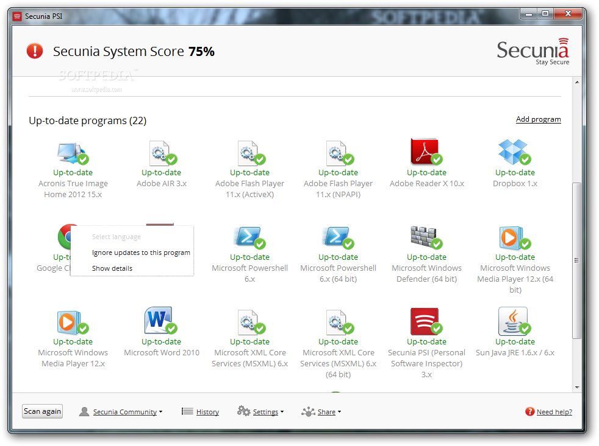 *Screenshot of Secunia Personal Software Inspector*

Useful Tools

* For managing Windows Products - Secunia PSI -https://www.flexerasoftware.com/enterprise/products/software-vulnerability-management/personal-software-inspector/
* For managing Windows Products - Ninite - https://ninite.com
* For managing Windows Products - Chocolatey -https://chocolatey.org
* For managing Apple OS X Products - https://www.munki.org/munki/

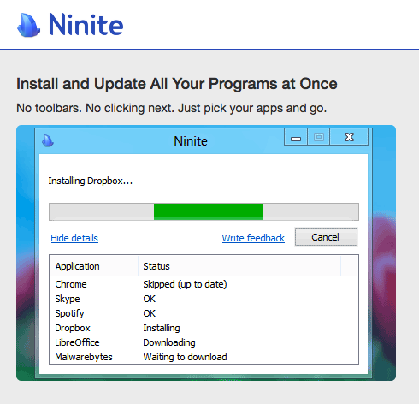  
*Screenshot of Secunia Personal Software Inspector*

The above tools have been chosen because of their ease of use, low cost and simplicity to show in a short training environment. We suggest soliciting other tools that may already be used by participants and/or letting groups research other tools that they may wish to test and discuss. We have chosen some of the following as they are widespread, have trial versions or have non-profit discounts through programs such as TechSoup. Some others that may be useful include:

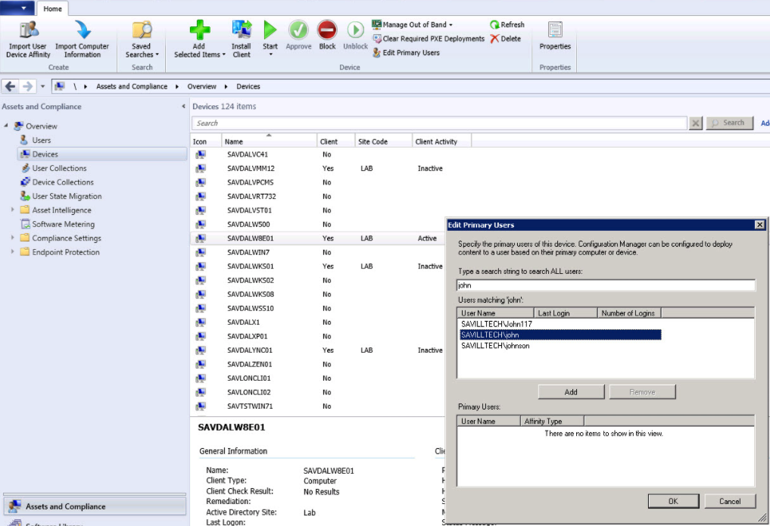 *Screenshot of Micorosft System Centre Configuration Manager*

* Microsoft System Centre Configuration Manager - SCCM - https://www.microsoft.com/en-US/cloud-platform/system-centre-configuration-manager
* GFI LanGuard - https://www.gfi.com/products-and-solutions/network-security-solutions/gfi-languard

Trainer Note: Highlight available tools and discounts with organisations such as TechSoup.

Each group should feedback on the product(s) that they tested.

## Deepening

Integrating into their organisations.

Following the previous discussion on software tools available to help manage deployment of software within an organisation. Ask individuals to break into groups depending on the type of software they believe is most relevant to them and then to create a plan for integrating the software into their organisation. It Should include topics such as:

* How many devices will it need to cover?
* How long would it take to implement?
* What costs would it take?
* What implementation problems might occur? How can these be overcome?

When individuals within the group reach a consensus, they should then add the plan to their own organisational assessments.

## Synthesis

Participants should turn to their assessment documentation and consider how their organisation deals with the subject matter covered in this module. Where necessary they should ask questions and work with other participants to identify any:

* Issues they have found that effect their organisations
* Possible solutions they have learned
* Possible difficulties they may face in implementation (ideally using the time ad experience of trainers and other participants)
* Things would need to overcome these difficulties
* Connections to other organisations or individuals that would help them
* Timeline, resources and costs for implementation

This should be noted in their assessment, for future use.

In line with keeping this curriculum as an updated community tool, we would also ask that participants provide comments, feedback and new ideas for this module on the project website and/or Github!

## Resources

* [Level-Up "Safer Software Updating](https://level-up.cc/curriculum/malware-protection/safer-software-updating/)
* [SAFETAG "Network Mapping," p.69](https://safetag.org)

# Network Management, Antivirus, Firewall, Wifi, Monitoring and Logs

### Introduction

This module is designed to be an introduction to some of the major tools and features that are available for a champion to begin implementing basic control of networks and security software within their organisations. It is a huge and complex topic, that would probably take weeks to address effectively. The idea is to highlight major tools and concepts, so that they can consider further exploration of them at some point in future. Also, the aim is to equip them with the basic knowledge that will allow champions to be able to understand and ask questions to effectively manage others will more expert skills in this area - outside consultants etc.

### Learning Goals

* Understand a basic network architecture
* Know how to locate and store logs
* Test conducting basic analysis of logs
* Identify and understand the positive/negative benefits of various intrusion detection systems, firewalls and antivirus software

### Assessment Goals

* Have a map of their network architecture
* Be able to find and store logs of devices used within their own organisations

### Recommend Preparations

N/A

### Suggested Time

75 minutes with 10 minute break

### Notes

N/A

## Activity

Ask participants to split into groups and draw network maps of all the tools, software and devices that they operate in their organisation.

Trainer Note: Not all participants will have an organisation with a traditional network infrastructure, in fact probably most won't. However, it is important to ensure that participants understand which services they are currently using and how they can monitor/log/manage each of them. There are a number of different ways for a network map to be drawn, but where a more traditional infrastructure exists, it will be important to point out items such as firewalls, DMZ, wifi, services, printers, backup drives etc., likely to be running.

In their groups, ask participants to find and check the logs on their devices. Even without specialist knowledge, what can we understand from them?

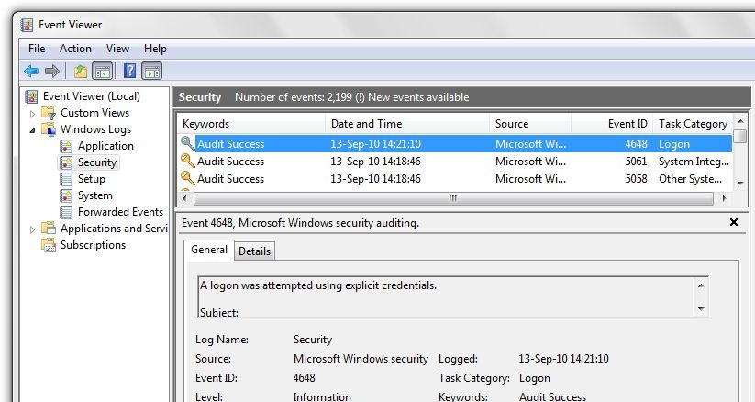

Event Viewer

* Windows 10 - https://docs.microsoft.com/en-us/windows/device-security/auditing/view-the-security-event-log
* MacOS - https://support.omnigroup.com/console-osx/

***Scenarios***  
(Trainer Note: this might be best used at the ed of the module): In groups, ask participants to run through a series of small scenarios and to document their responses. Examples include:

* A colleague reports that they have accidentally clicked on what they think may have been a spear-phishing email.
* Another organisation in the community sends you an encrypted mail informing you that they have been the victim of hacks that they have traced to an IP address they have confirmed that has been used by adversarial hackers. How can you use this IP address toe ensure you will not be targeted by the same group?
* Sensitive internal organisational data has been leaked by malicious hackers online. You suspect that it must be due to a hack - what actions might you take?

## Discussion

* What type of network is used by each organisation that the participants are from?
* What type of antivirus, firewall and/or intrusion detection do we use on our devices?
* What are the advantages and disadvantages of a self-hosted network?
* What are the benefits and advantages of a "cloud" network?
* Who is responsible for managing the network?
* If the participant or another individual is responsible, how do comfortable do they feel to manage, secure and verify the integrity of the network?
* If an outside individual or contractor is responsible, do they trust them? What measures can they take to ensure their network is being managed properly?
* What experiences have participants had using specific tools and/or techniques to manage a network? Monitor antivirus reports? Monitor a network? Store and view logs?

## Inputs

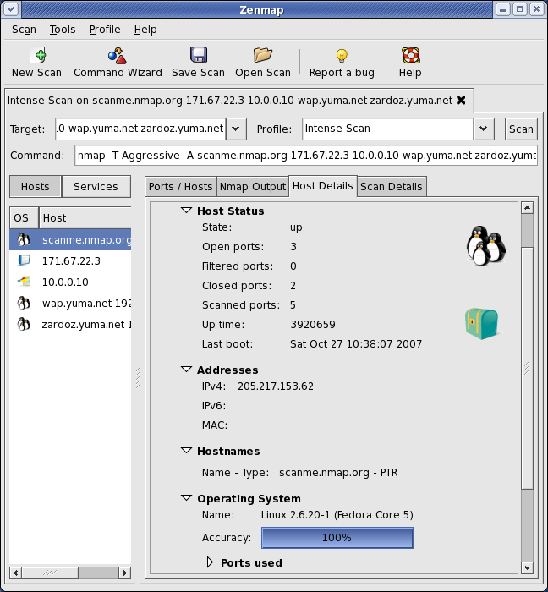

Zenmap

***Networking Mapping with Nmap/Zenmap GUI/Maltego***

The trainer should introduce visual tools such as Zenmap and Maltego to demonstrate the process of mapping a network. Emphasis that this is likely to be one of the first actions to be taken by an attacker. It is important to know what assets are connected to the network and what an attacker will see.

Trainer Note: NMap and other tools can be fairly complex to master and training in the full, safe, usage of them is probably left to other courses (for example, SAFETAG has excellent resources on it's use), the primary aim is just to give a quick visual demonstration. Also, in order to avoid the problems of scanning a training location network etc. - it is recommended to record a network scan on a network you are allowed to scan and then run it during the training session.

***Event Viewing***

Highlight the management features of tools such as :

* Windows Event Viewer: https://technet.microsoft.com/en-us/library/cc749408.aspx
* MacOS - http://www.macworld.com/article/3102847/macs/hands-on-with-macos-sierras-console-now-its-easier-to-get-the-mac-information-you-need.html
* Linux - https://www.lifewire.com/introduction-to-linux-log-files-2192233
* Chromebook - https://support.google.com/chrome/a/answer/3293821?hl=en
* G-Suite https://gsuite.google.com/products/admin/

Highlight the utility of tools for easy self hosting such as:

* A demonstration of Sandstorm and/or Cloudron (available on their websites)
* A demonstration of OwnCloud / NextCloud

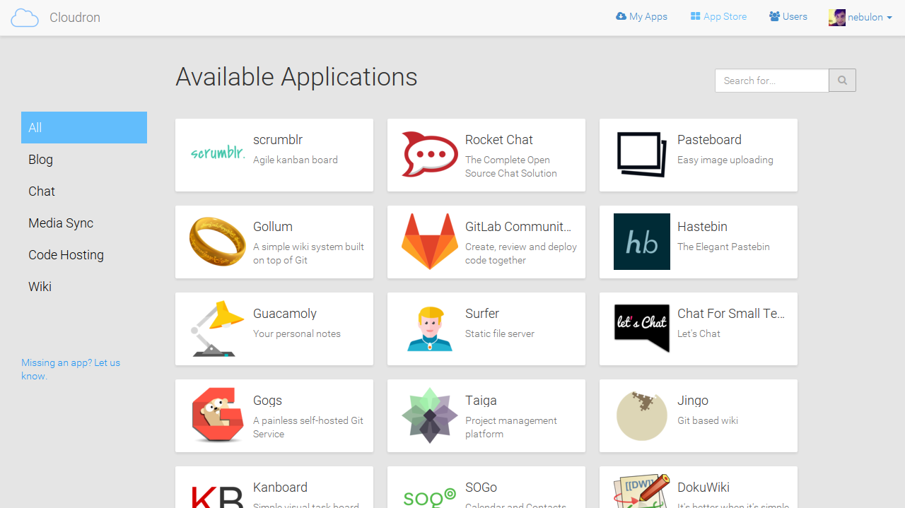

Cloudron

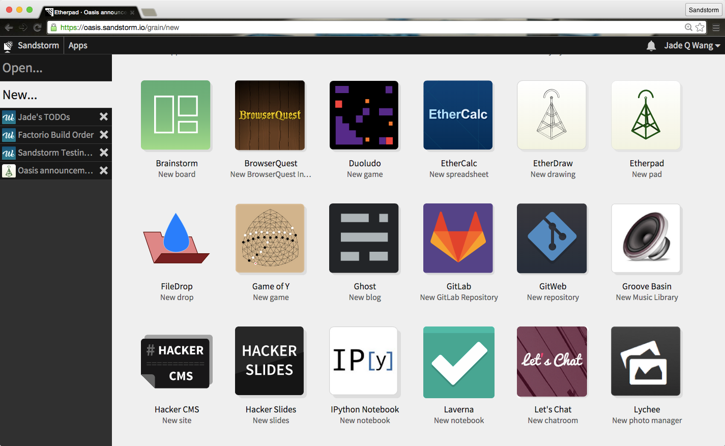

Sandstorm

## Deepening

***Antivirus, Firewalls and Intrusion Detection Systems***

Definitions

* Antivirus: a type of software designed to prevent, detect and fix malware infections. Example: Windows Defender
* Firewall: software or physical device that monitors traffic to/from your computer and blocks based on a set of rules. Example: Little Snitch for macOS.
* Intrusion Detection System: software or a physical device that monitors systems or a network for malicious activity or policy violations. There are two main types Signature detection (looking for known malicious traffic) and Anomaly Detection (taking a baseline of activity and then looking for unusual activity that occurs after that). Example: Snort (Cross Platform)

Some points to emphasis:

* Ensure users are aware that Macs and phones can also suffer from malware, so ensure protection is available.
* While many professionals believe that antivirus software is no longer useful, that is because many have a strong information security knowledge and do not represent the practices of an average user.

Break participants into groups, ask them to take one or two types of tool and experiment with them. Most participants will already be familiar with basic antivirus tools, such as those on a single device. The objective of this exercise is to get them to:

* Test how to deploy and manage antivirus, firewalls and IDS are managed centrally. This provides a better overview of an organisation.
* Where it is not possible for an organisation or individual to manage centrally, be able to deploy tools quicker than with just regular manual inputs.

Trainer Note: Many of the open source tools available are unfortunately likely to be difficult for participants without a very high technical background to deploy and manage. As such, we recommend highlighting the available tools tools that are available with signficant non-profit discounts from organisations like Techsoup. 

Users should research commonly found tools to see what is available. Though we recommend starting with (because trial versions are for download and full versions are on TechSoup):

* Norton for Small Business
* Bit Defender Gravity Zone
* Comodo Endpoint Security Manager

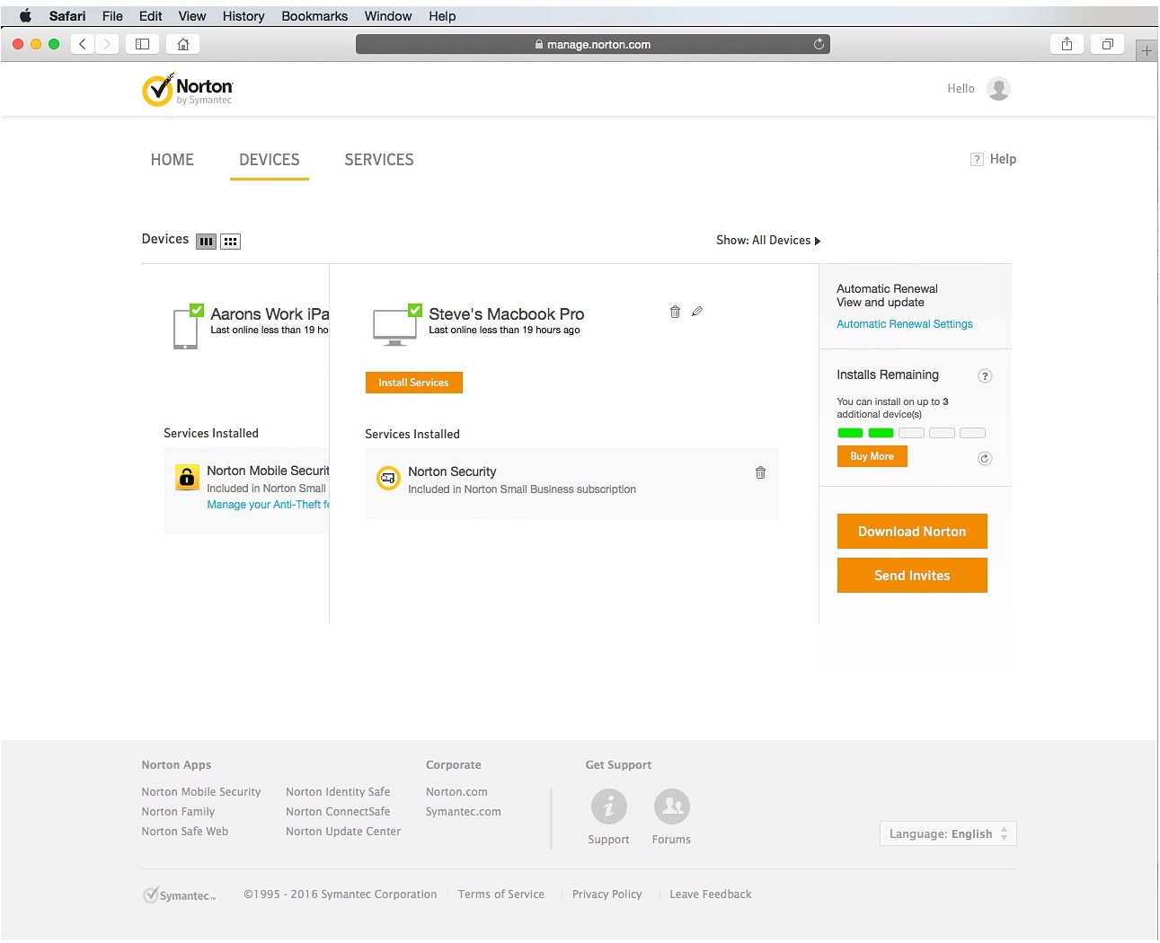

Norton Small Business

Open source Firewalls:

* PfSense - https://www.pfsense.org
* Untangle Firewall - https://www.untangle.com
* ClearOS - https://www.clearos.com/



Snort

Opensource Intrusion Detection Systems:

* Snort
* Suricata
* Bro
* OSSEC

Trainer Note: Open source IDS systems usually require a significant amount of time to setup initially and/or being comfortable with using command line/Linux.

***WiFi***  
One method for penetration an organisation is through attacks on WiFI. These mainly take two forms, attacks on weak WiFi security and the use of rogue access points.

Some methods to reduce WiFi risk include:

* Attacks on weak wifi security usually involve routers usinig a weak protocol such as WEP. It is best to set your routers to WPA2 if possible.
* Change the WiFi name (SSID) to something that is not easily recognisable as connecting to your organisation.
* If possiible, have a second wifi connection for public or visitors with a different SSID and password.
* WiFI passwords should be strong and of an appropriate length (e.g more than 12 characters with a mix of numbers, letters, uppercase/lower case etc)
* Ensure the SSID and passwords are changed on a regular basis
* Monitor the number of devices on your WiFi
* Use a MAC address filter which devices can connect (though this can be spoofed)
* Using a wired ethernet connection
* Utilise a VPN

  
*Example of a WiFI Pineapple - a popular rogue access point*

Another potential risk is from rogue access points. These are routers, phones or laptops that have been placed near to your home and residence in order to try to gain access to your network or man-in-the-middle your communication. The utilise a number of methods to try to do this, such as creating a fake WiFi network with the same or similar name to your real network.

Some of the easiest ways to reduce the risks from rougue access points are:

* Check for any SSIDs that are similar to ones used in your office.
* Ensure your router strength only broadcasts over the areas that you need it (for example, the office) and not further than necessary (e.g other parts of the building where someone could try to connect easily without being discovered). Test this by mapping out the location of WiFi devices in your building using a tool such as [Netspot](https://www.netspotapp.com), [NetStumbler](http://www.stumbler.net) or [Airmon-ng](https://www.aircrack-ng.org/)
* Monitor your physical space for equipment that should not be present (for example, rogue access points hidden in a roof or cupboard).
* If using network authentication, use certicates to limit the ability of any rouge access point.
* Use tools such as [Nessus](https://www.tenable.com) to scan the network to look for known rogue access point tools.

## Synthesis

Participants should turn to their assessment documentation and consider how their organisation deals with the subject matter covered in this module. Where necessary they should ask questions and work with other participants to identify any:

* Issues they have found that effect their organisations
* Possible solutions they have learned
* Possible difficulties they may face in implementation (ideally using the time ad experience of trainers and other participants)
* Things would need to overcome these difficulties
* Connections to other organisations or individuals that would help them
* Timeline, resources and costs for implementation

This should be noted in their assessment, for future use.

## Resources

* [SAFETAG, "Network Scanning," Page 60](https://www.safetag.org)
* [Guide for System Administrators in At‐Risk Organizations: "Network Security"](https://github.com/OpenInternet/System_Administrator_Guide_Text/blob/master/en/best_practices/network_security/index.md)
* [NIST: "Guide to General Server Security"](http://csrc.nist.gov/publications/nistpubs/800-123/SP800-123.pdf)
* [NIST: "An Introduction to Computer Security"](http://csrc.nist.gov/publications/nistpubs/800-12/handbook.pdf)
* [NIST: "Guide to Intrusion Detection and Prevention Systems (IDPS)""](http://csrc.nist.gov/publications/nistpubs/800-94/SP800-94.pdf)
* [SANS "Critical Security Controls"](https://www.sans.org/critical-security-controls/controls)
* [SANS "Detecting and Preventing Rogue Devices on the Network"](https://www.sans.org/reading-room/whitepapers/detection/detecting-preventing-rogue-devices-network-1866)
* [Information Ecology: Public Wireless](https://0xacab.org/iecology/security-checklists/blob/master/6_public_wireless_checklist.md)

# Communications

### Introduction

Communications are often one of the most vulnerable parts of any organisations work. Even if internal communication measures are strong, often the most difficult part is securing conversations and information flow from people at risk - such as victims and sources. They often lack the technical knowledge or toolks to be able to create and sustain and effective channel of secure communications. Also, tools and techniques change rapidly and that can often leave a patchwork of systems - secure/insecure, not interoperable, with poor useability etc.

The aim of this module is to encourage champions to select a suite of tools that will then allow them to create a simple, but consistent, framework for their organisations commmnications.

### Learning Goals

* Understand the variety of communications conducted by the organisation
* Understand the security vs. usability aspects of communications tools and techniques that are/will be used by the organisation

### Assessment Goals

* Develop a communications plan for their organisation based on the scenarios they face - day to day, internal, first contact, working with partners etc.

### Recommend Preparations

N/A

### Suggested Time

45 minutes

### Notes

## Activity

Ask participants to split into pairs. Designate one of the pair as a person seeking help (the "activist") in the field and the other as a person in their own organisation ("the staff member"). Ask them to run through scenarios such as the following:

* The activist is high profile and has often been harrassed by their local government. They are travelling out of the country and fear being detained at the airport. The staff member should advise them what to do.
* The activist has a friend who has been arrested at a protest with their laptop, camera and mobile phone. The staff member should advise them what to do.
* The activist is a whistleblower with information on widepspread government humanrights abuses. They call your organisation on their regular mobile phone looking to provide information. The staff member should advise them what to do.
* The activist calls to say that their home and office have been raided by the hostile local police. The staff member should advise them what to do.

## Discussion

Ask participants to outline their regular communication needs by listing on post-it notes or a flip board:

* What communication tools their organisation users
* What non technical controls for communication are used within their organisation (e.g. compartmentalisation, "need to know")
* Who they have to communicate with, both inside and outside of their organisations
* When they have to communicate
* Scenarios or case studies that they have to deal with (e.g. dealing with a source with low technical skills in an area of poor infrastructure)
* What methods of managing communication within the participants organisations have been effective/ineffective?
* What methods have been used to help overcome these challenges?

## Inputs

Many organisations face similar problems. Staff often struggle to figure out what information to protect and how. Information policies are often not linked to other policies about secure data and communication etc.

Some organisations have tried to make this easier by creating simple systems using traffic lights (Red/Yellow/Green). For example, many governments use it to make it less complex to when know information can be shared.

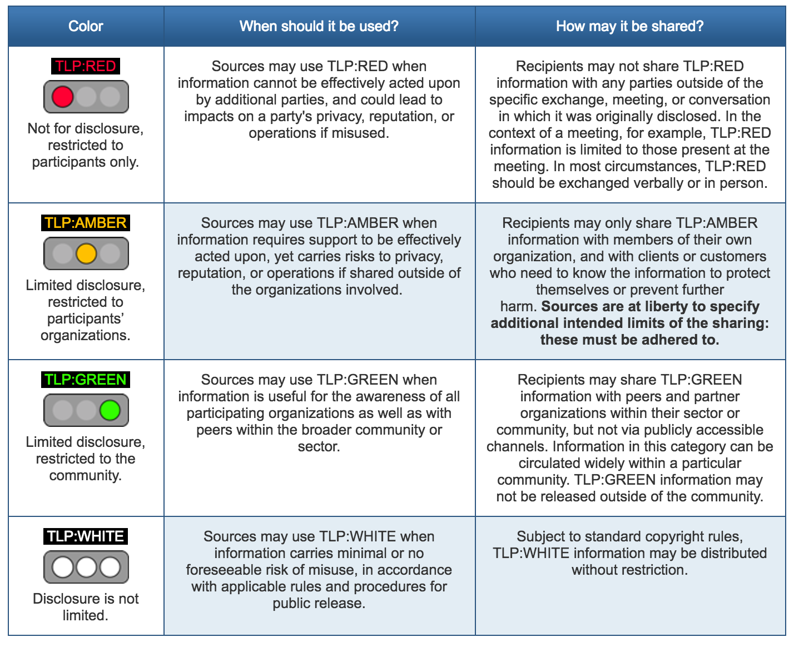 Example of a traffic light protocol recommended by [US-CERT](https://www.us-cert.gov/tlp).

Some examples of using such a system within civil society groups might include:

* Press releases might not be sensitive, so it would be considered Green and can be stored on any regular system.
* Employee data such as bank details is sensitive should be marked as Yellow and then only be stored on an encrypted hard drive.
* Source data such as sensitive leaks is highly sensitive data, so should be marked as Red. It should always been encrypted both at rest (on a hard drive) and in transit (when communicating with the source). It should only be accessible by people with a "need to know."

It is useful to add simple policy rules about tools and techniques to make sure a system work. For example: Tools:

* Green - Regular Email (including personal), Slack, Skype
* Yellow - Protonmail/Tutanota, WhatsApp, Jitsi Meet, Psiphon VPN
* Red - PGP Encrypted Email, Signal, Tor

Techniques:

* Green - Free to speak about the information to anyone of interest
* Yellow - Information should be get confidential in the office, paper copies should be locked away and shredded when not in use, all staff sign a non-disclosure agreement, have done training
* Red - Compartmentalised information control, "need to know" only, participants only read into the project when necessary, use of new accounts not connected to other work to reduce metadata

## Deepening

The group is now going to be divided up into groups of approximately four people. Each group is now going to try to build a Communications Plan based on the examples provided in the inputs.

On a flipchart/post-it notes and/or a hackpad divide and utilising some of the previous work done during the discussion, ask participants to divide up answers to following into the categories of Green/Yellow/Red:

* What information are we trying to communicate?
* What tools should we use?
* What techniques should we use?
* What do we need to do to implement this within the organisation?

Example:

YELLOW - Donor information about future projects - ProtonMail, WhatsApp - Password protect all documents with password over 16 characters, only speak to them about sensitive topics in person - Ask donor to setup ProtonMail account for sensitive information, set monthly calendar reminder to periodically remind them to delete WhatsApp conversations with us.

***Interactive Online Training***

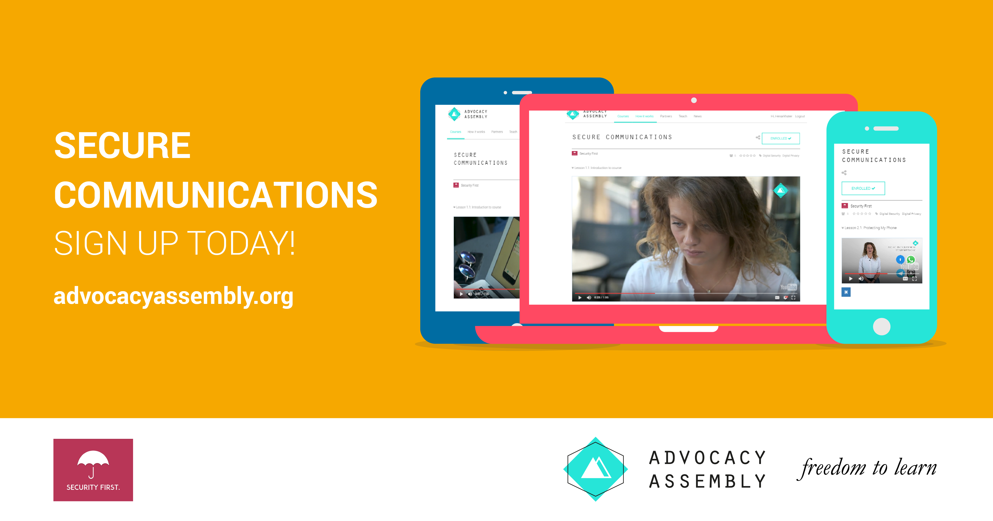

Advocacy Assembly Communications Course

For champions working with individuals remotely or who do not have the time to be able to train others in person. A free online short (20 minute) course with video and quizzes on communications designed by [Security First](https://wwww.secfirst.org) is available in English, Arabic and Farsi for free on [Advocacy Assembly](https://advocacyassembly.org).

## Synthesis

Participants should turn to their assessment documentation and consider how their organisation deals with the subject matter covered in this module. Where necessary they should ask questions and work with other participants to identify any:

* Issues they have found that effect their organisations
* Possible solutions they have learned
* Possible difficulties they may face in implementation (ideally using the time ad experience of trainers and other participants)
* Things would need to overcome these difficulties
* Connections to other organisations or individuals that would help them
* Timeline, resources and costs for implementation

This should be noted in their assessment, for future use.

In line with keeping this curriculum as an updated community tool, we would also ask that participants provide comments, feedback and new ideas for this module on the project website and/or Github!

## Resources

* [Umbrella App: Communications Section](https:///www.secfirst.org)
* [Security in a Box: "Keep your online communication private"](https://securityinabox.org/en/guide/secure-communication/)
* [EFF Surveillance Self Defence: "Communicating with others"](https://ssd.eff.org/en/module/communicating-others)
* [Guide for System Administrators in At‐Risk Organizations: Physical Security](https://github.com/OpenInternet/System_Administrator_Guide_Text/blob/master/en/best_practices/staff_awareness_and_communications/index.md)
* [Wikipedia: Traffic Light Protocol](https://en.wikipedia.org/wiki/Traffic_Light_Protocol)

# Physical Security

### Introduction

The physical security of devices is a common issue faced by people in the Champion role. Also, it is very easy to focus purely on digital tools and forgot physical information, such as paper documents and files etc. Civil society groups are also increasingly at risk because of the use of harrassment activities such as office raids, arrests and device seizure at borders etc. Many secure mitigations can be negated if physical access to the device is gained. This module aims to look at security measures that an organisation can to manage and mitigate physical security threats.

### Learning Goals

* Understand the layering system of physical security
* Map the physical location of the training as an example of physical security assessment
* Identify various physical security controls and their strengths/weaknesses

### Assessment Goals

Select physical controls that might be relevant to their own home/office environments

### Recommend Preparations

If conducting the red team exercise, ensure to plan for any security issues that may occur by accident. Inform other people in the training location etc.

### Suggested Time

45 Minutes

### Notes

N/A

## Activity

**Red Team Exercise**  
Participants will be broken into pairs and asked to do a draw and write a basic physical site security assessment. (Trainer note: this can often look very suspicious, so it is best to notify people at the training location that this will be occurring. Also to tell participants to be discrete and what to say if they are asked what they are doing. Whether this exercises goes ahead depends on your initial training setup risk assessment).

Participants should start from outside the training location and move inwards all the way to the exact room where the training is being conducted. They should be asked to think like a "red team" or someone trying to gain access to devices physically located in the training room. They should draw and/or write security weaknesses and strengths that they see along the way and provide mitigations where necessary. For example, they may notice that their is a receptionist at a front door but that someone can easily gain access through a car park. They may see that CCTV blocks the way but the cameras are not watched and it's possible to gain access to the training room without being stopped, as it is difficult for people to know who is a stranger. Once in the room, they may notice that there is no place to lock away laptops and that some of them are unattended and without a password.

## Discussion

* What physical security incidents have participants experienced or heard about?
* How might these be mitigated?
* What did we learn from the red team exercise?
* What positive security features are there?
* What negative security features are there?
* How might we mitigate the negative security features?
* What would be the hazards if people could gain access to the participants homes and offices?

## Inputs

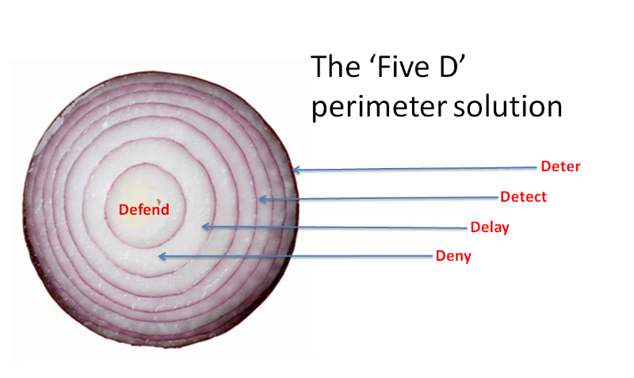

Security Onion

It is useful to consider physical security as we might consider digital security - the layers of an onion. Layered defences act as a deterrent. The more layers that an adversary has to peal the more space and time they have to be exposed and that we have to potentially apprehend them.

It can be useful to consider physical security risks by referring the information gathering cycle that an adversary may de facto use (whether they a petty thief or a sophisticated government). In this, the adversary is most exposed (and thus most likely to be caught) when they are conducting surveillance of a physical location. This is the time when they must position themselves in such a way that they can observe your location. For example, a thief wishing to steal IT equipment may position themselves so they can observer when people leave your location in the evening, so that they know when it is a good time to break into the building.

When building our layers of the physical security onion, we often tend to think purely of physical objects such as walls, locks, cameras and doors. It is important to also consider other factors that act as layers and provide early warning of problems, for example friendly people in the local community, neighbouring organisations, sympathisers amongst potential adversarys etc.

## Deepening

***Security Strategies***  
Security strategies used by civil society groups generally use one or more of the following methods:

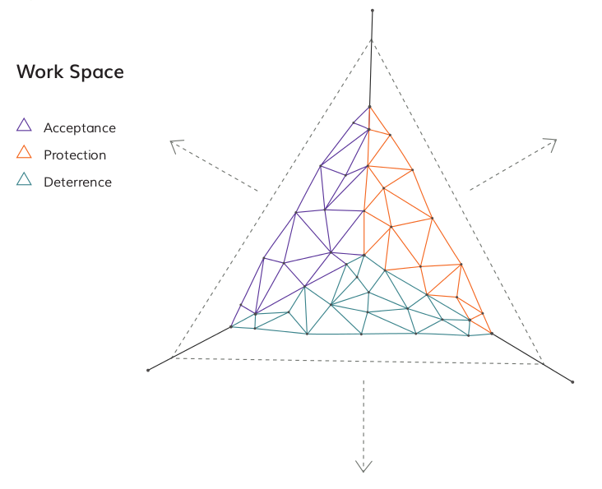 Source: [The Holistic Security Manual](https://holistic-security.tacticaltech.org)

* Acceptance - being welcomed within a community and without adversaries who may seek to do you or your organisation harm
* Protection - using methods to defend yourself from harm
* Detterance - creating fears within adversaries that they may be retaliated against if you are harmed

***Identifying Physical Surveillance***  
There is a lot about the process of physical surveillance and identifying it in [Umbrella App](https://www.secfirst.org).

## Synthesis

Participants should turn to their assessment documentation and consider how their organisation deals with the subject matter covered in this module. Where necessary they should ask questions and work with other participants to identify any:

* Issues they have found that effect their organisations
* Possible solutions they have learned
* Possible difficulties they may face in implementation (ideally using the time ad experience of trainers and other participants)
* Things would need to overcome these difficulties
* Connections to other organisations or individuals that would help them
* Timeline, resources and costs for implementation

This should be noted in their assessment, for future use.

In line with keeping this curriculum as an updated community tool, we would also ask that participants provide comments, feedback and new ideas for this module on the project website and/or Github!

## Resources

* [Guide for System Administrators in At‐Risk Organizations: Physical Security](https://github.com/OpenInternet/System_Administrator_Guide_Text/blob/master/en/best_practices/physical_security/index.md) # Travel

### Introduction

Travel is often the time when individuals are most at risk. Civil society members are often exposed to both regular risks in a place and increased risks specifically because of who they are and what they do. They are often in locations they are unfamilar with and may rely on others for parts or all of their security. Also, individuals may have to travel through places such as airports or hotels, where devices may be seized or networks monitored. Moreover, it is often difficult for a Champion to know exactly what the information risk may be in the new location, so methodology and tool choice can be complex - especially where infrastructure is poor. This module deals with some methods for securing information when travelling.

### Learning Goals

* Understand how to threat model the locations where they or their team may travel to - including law and operational aspects
* Learn how to best prepare equipment and systems for travel (e.g. "clean" laptop)
* Discuss the advantages/disadvantage of Remote Access

### Assessment Goals

* Conduct basic information security travel assessment for the locations where they travel to
* Add information security to any existing travel planning documentation they already have

### Recommend Preparations

N/A

### Suggested Time

45 mins

### Notes

## Activity

**Travel Briefing Game**

* Participants are split into groups of two people. One person will be a colleague about to travel to a nearby country (given by the trainer). The other person will be designated the as the IT person who needs to brief their colleague on the what information security measures they should take when travelling to the country. (Trainer Note: Try to pick real countries that the participants are likely to use. Where possible have a mix of different information security risks - e.g. device seizure, malicious hotel Wi-Fi etc.).
* The participants who are conducting the briefing have ten minutes to come up with a very quick plan and then will have five minutes to communicate verbally that information to their "colleague"

***The should cover issues such as:***

* What are known risks in the country? What previous relevant incidents have occurred?
* What potential issues may they face when entering, in, leaving the country? (e.g. malicious updates sent to phone, theft of equipment, "evil maid" attacks)
* What are the recommended methods for mitigating the identified risks? (e.g. VPN usage, use of clean laptop)
* What actions need to be taken for implementing the mitigations? (Purchase VPN, need to plan for a number of hours to securely wipe the "clean laptop" etc.)

Trainer Note: If time permits, the individual designated as a colleague can also practice this process. There role is to act as the IT person and they must create a similar plan and send it to an activist in the field who is leaving a country to come and attend a training. Instead of verbally, this plan should be sent via a secure method such as encrypted mail or Signal. The objective of this exercise is to create test two common scenarios that a champion finds themselves having to deal with.

## Discussion

* What type of threats do participants and their organisations face when travelling?
* What have been their previous experiences?
* How commonly do they happen?
* What tools and techniques have been used for mitigating problems when travelling?
* What resources do participants use for threat modelling when they travel or are asked to advise others in their organisation how to travel safely using devices?
* How can this process be managed and integrated by participants into their own organisations?

## Inputs

***Travel Tools***  
There are a number of guides for information security when travelling.

For example:

* [EFF - Travel Screening](https://www.eff.org/issues/travel-screening)
* [Umbrella App - Travel Sections](https://www.secfirst.org)
* [University of Arizona: Guidelines for International Travel](https://security.arizona.edu/security-guidelines-international-travel)

***VPN Choice***  
VPN choice for an organisation is often tricky. Champions often find themselves asked questions about which services are best to use. [That One Privacy Site](https://thatoneprivacysite.net) has been created to make it easier to compare features such as privacy, cost, and logging.

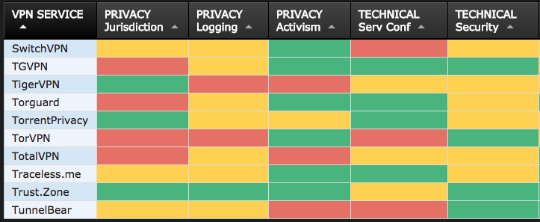 *Example of the comparison on "That One Privacy Site"*

## Deepening

**"Clean" Laptop**  
A number of organisations issue an older or spare laptop for travelling.

**Delete and Download**  
Another technique is to securely delete information from a device, travel to a destination and then download from there. Often this can cause a number of problems though, especially if the local internet connection is poor and/or people are reluctant to delete files/mails etc. stored locally. Especially this can be a problem for personal mobile phones.

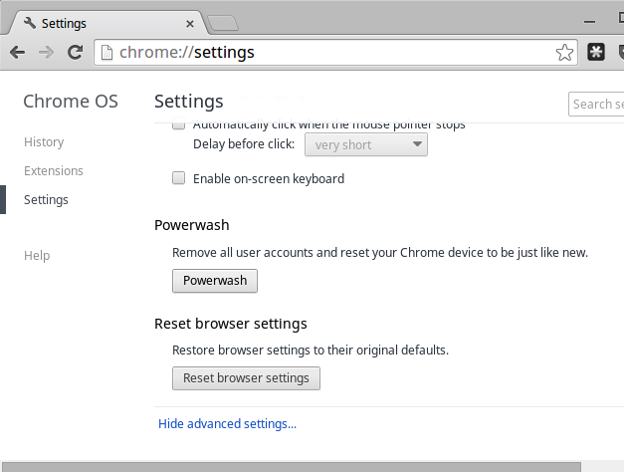

Chrome Powerwash

**Chromebook "Powerwash" Feature**  
Many organisations utilise G-Suite and/or Chromebooks as cheap, easy to use travel laptops. One of the useful features of the Chromebooks is called "Powerwash." This allows users to easily wipe local data, travel to a location and then restore user accounts later on.

**Remote Access**  
There are a number of systems available to allow organisations to manage remote access. This can often be a useful method of security when access

TODO: INSERT REMOTE ACCESS OPTIONS

## Synthesis

Participants should turn to their assessment documentation and consider how their organisation deals with the subject matter covered in this module. Where necessary they should ask questions and work with other participants to identify any:

* Issues they have found that effect their organisations
* Possible solutions they have learned
* Possible difficulties they may face in implementation (ideally using the time ad experience of trainers and other participants)
* Things would need to overcome these difficulties
* Connections to other organisations or individuals that would help them
* Timeline, resources and costs for implementation

This should be noted in their assessment, for future use.

In line with keeping this curriculum as an updated community tool, we would also ask that participants provide comments, feedback and new ideas for this module on the project website and/or Github!

## Resources

* [Guide for System Administrators in At‐Risk Organizations: Know your Rights](https://github.com/mahvashtaqi/System_Administrator_Guide_Text/blob/master/en/best_practices/know_your_rights/index.md) # Responding to Incidents

### Introduction

Dealing with incidents once they have occurred is an important part in mitigating the effect of overall risks within an organisation. Champions within civil society groups must deal with everything from lost phones to sophisticated government attackers. This module highlights some services that can be utilised in the event of incidents occuring and also some useful references that can be used for helping champions prepare and respond to incidents.

### Learning Goals

* Understand commons information security problems effecting civil society groups
* Understand frameworks for dealing with information security incidents
* Explain first line response procedures for potential incidents
* Describe the different offerings of various groups who can help - timescale, resources etc.
* Understand what is needed for forensic analysis at a later point

### Assessment Goals

Add incident response plan for major information security risks to the assessment

### Recommend Preparations

N/A

### Suggested Time

45 Minues

### Notes

N/A

## Activity

**Incident Simulations**  
Break participants into two groups. Each will be given a different scenario.

***Scenario One*** A hacking group hostile to your organisation has sent out a tweet with screenshots of a few sensitive internal files containing information on the pay and personal details of a few of the staff. They say this is just the beginning and they have access to lots more. What will you do?

***Scenario Two*** A colleague of yours in travelling for the past week in a high risk country to gather sensitive evidence from witnesses about human rights abuses in a country. They recently called you to say they were arrested by intelligence officials of the local government on the way to the airport. They could not say any more. You can assume they have all of their sensitive information and devices with them. What will you do?

Trainers Note: It is often most productive to assign specific roles to individuals within the groups themselves, in order to stimulate discussion and also to ensure that a variety of viewpoints are being represented. Experience shows that people often under estimated who is involved in responding to incidents and how much of their time and resources are necessary. For example, in scenario two, some of the roles could include people such as:

* IT Champion
* Organisational Director
* Social Media or Public Relations Manager
* Family of the staff member
* Individual who provided testimony and is now concerned
* Finance team
* Embassy representative of the person detained
* Government representative of the person detained or of the country which detained the individual
* Google/Facebook/Cloud host Representative (if the group decides they want to have )

## Discussion

* What lessons did we learn from the scenarios?
* What did we think we handled well?
* What did we think we did not handle well?
* How could we make ourselves better prepared to deal with incidents?
* Who might be involved with responding to incidents in our own organisations?
* What sort of incidents do we think this process would be useful in helping us address?

## Inputs

There are a number of sources of support for civil society groups when they experience a digital security incident.

These include organisations such as:

* [Access Now](https://www.accessnow.org/)
* [Security without Borders](https://www.securitywithoutborders.org/)
* [Digital Security First Aid Kit](https://www.digitaldefenders.org/digitalfirstaid/)
* [Security First](https://www.secfirst.org)

## Deepening

Paticipants will now break into groups to conduct discussions where they review best practice documentation on how to respond to incidents. The should examine each document and discuss points such as:  
-How useful is the document?  
-Do the understand everything I would need to be able to use it correctly?  
-What would the need to add, remove or modify to make it useful for themselves?

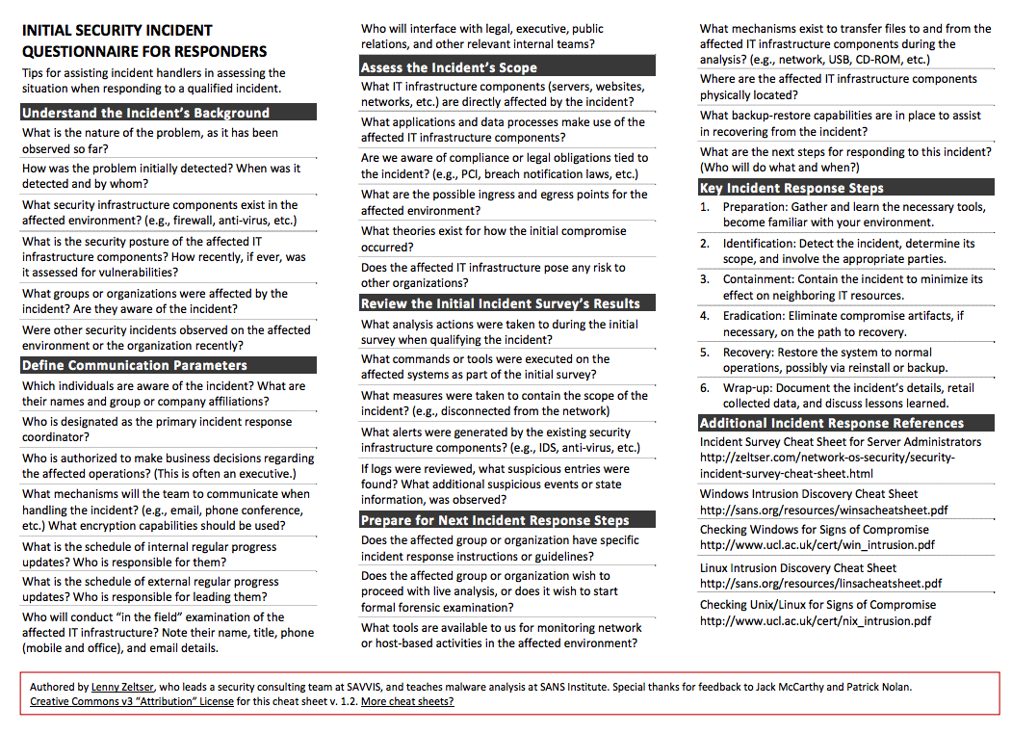

Zelstser Incidnet Questionnaire

Examples of basic incident reponse documentation include:

* [Lenny Zelstser's "Initial Security Incident Questionnaire for Responders - example above](https://zeltser.com/security-incident-questionnaire-cheat-sheet/)
* [SANS Incident Handler's Handbook](https://www.sans.org/reading-room/whitepapers/incident/incident-handlers-handbook-33901)
* [OWASP Top 10 Considerations For Incident Response](https://www.owasp.org/index.php/OWASP_Incident_Response_Project)
* [OWASP Anti-Ransomware Guide](https://www.owasp.org/images/4/4a/Anti-RansomwareGuidev1-5.pdf)

## Synthesis

Participants should turn to their assessment documentation and consider how their organisation deals with the subject matter covered in this module. Where necessary they should ask questions and work with other participants to identify any:

* Issues they have found that effect their organisations
* Possible solutions they have learned
* Possible difficulties they may face in implementation (ideally using the time ad experience of trainers and other participants)
* Things would need to overcome these difficulties
* Connections to other organisations or individuals that would help them
* Timeline, resources and costs for implementation

This should be noted in their assessment, for future use.

In line with keeping this curriculum as an updated community tool, we would also ask that participants provide comments, feedback and new ideas for this module on the project website and/or Github!

TODO  
-Conduct a series of short scenarios games based on the most likely threats risks faced by the participants in the training. -Emphasis the need for threat information sharing. Suggest methods for doing that (procedural - NDA etc.) and technical (IOC, MISP etc.)

## Resources

# Resilience, Continuity and Backups

### Introduction

In earlier modules, we identified that if we want to lower risk, we can either reduce the likelihood that something will occur or to reduce it's effect if it does occur. There is often a tendancy to focus on the preparation and not the aftermath. This chapter attempts to deal with this by considering some tools we can use for creating resiliency within organisations.

### Learning Goals

* Understand the strength and weaknesses of self-hosted vs. cloud hosted
* Understand the various tools available for secure end-to-end hosting and backups
* Understand basic business continuity concepts

### Assessment Goals

* Add a specific backup solution to the assessment (if not already using one)
* Add a basic business continuity plan if relevant

### Recommend Preparations

Print off example business continuity plans in advance.

Participants are likely to be already familiar with a number of the tools, yet they may not have had an opportunity to use the management features of many of them. To make training environment setup easier

### Suggested Time

30 Minutes

### Notes

N/A

## Activity

N/A

## Discussion

With post-it notes or flipchart, ask participants to list:

* What do they consider by the term "resilience" within their own organisations?
* What type of resilience incidents might occur? (e.g fire, office raid, rioting, drive failure etc.)
* What back-up services do they currently use?
* What size backup storage they need as individuals and as organisations?
* What and where is the data that needs to be backed up?
* Where are the backup locations? (e.g onsite, offsite)
* Have backup services been fully tested? (they often fail)
* What steps would be needed to ensure operations and communications continue?
* Is it an option for staff to work remotely (such as at home)?
* Is there an inventory of assets such as laptops, drives, phones etc? Are they covered by insurance? Are appropriate proof of purchase reciepts and warranties kept?

The advantages and disadvantages of theses methods/services for issues such as:

* Security
* Size/cost
* Usability
* Management Control

## Inputs

Business continuity is defined as the capability of the organization to continue delivery of services and or operations at acceptable predefined levels following a disruptive incident. There are many methodologies for managing business continuity.

What sort of incidents do participants believe they would consider disruptive?

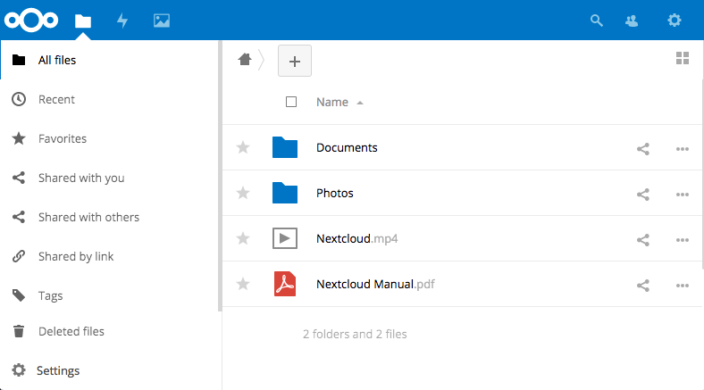 *Next Cloud is an open source, self hosted backup tool*

There are a number of methods for small organisations implementing simple methods for backups and resiliency. These include:

* Self hosting on their own internal network - e.g. Microsoft File Sharing, NextCloud
* Self managing in the cloud - for example using Amazon Web Services, Digital Ocean or Eclips.is to run a server with backup applications that you control - e.g. NextCloud, Syncthing, Sparkleshare
* Propriety cloud backups - e.g. Dropbox, One Drive or Google Drive
* Propriety cloud backups with an extra layer of encryption - e.g. Dropbox or Google Drive with Cryptomator
* Proprietary cloud backups with end to end encryption - e.g. Tresorit (offers 10 free users for Non-profits) or Spideroak

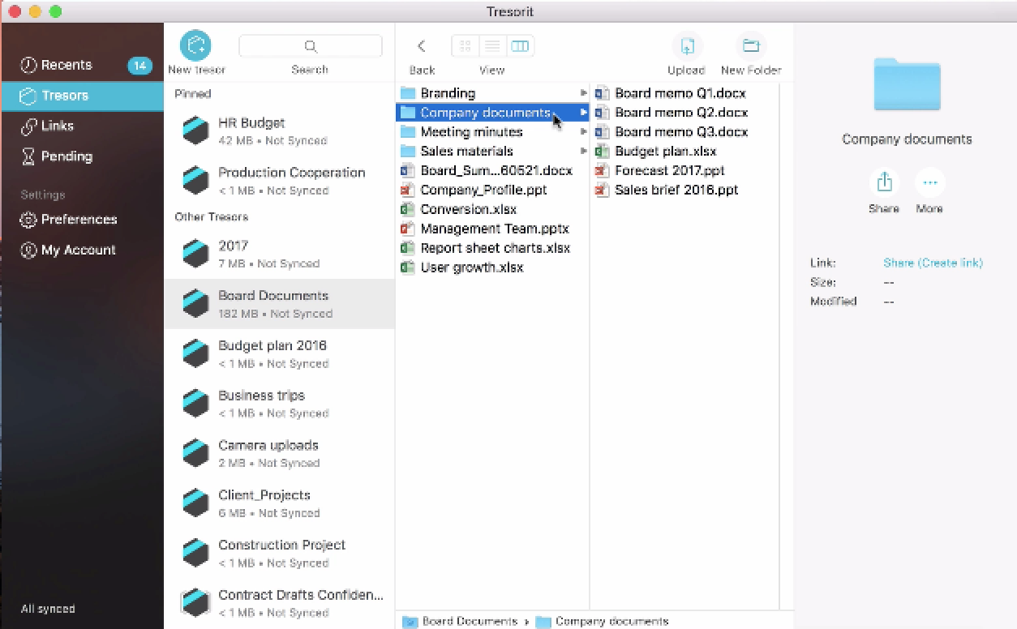 *Tresorit is closed source, end-to-end encrypted tool*

***Business Continuity*** An important aspect of ensuring an organisation is resilient, is the process of Business Continuity Planning (BCP). Many smaller civil society organisations feel that this is not relevant to them, however, plans do not have to be complex. Also, many organisations face a variety of threats unique to them - from office raids to hacktivists.

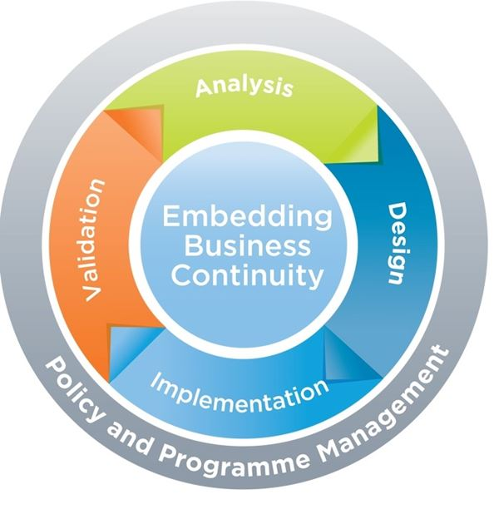

BCM Lifecycle

When working out the time periods It is recommended to divided the are divided into segments of time such as the following:

**Reduce** - the period of time before the disaster.

**Response** - the hours and days immediately following the disaster.

**Recover**- the period from the occurance of the disaster until temporary operations or alternative processing are executed.

**Resume** - the time whereby business functions and operations are resumed at alternate site.

**Restore** - the restoration of non-critical functions and damaged infrastructures.

**Return** - the time when operations return to normal.

Source: [Goh, Moh Heng (2008). BCMPedia. A Wiki Glossary for Business Continuity Management, BCM Institute.](http://www.bcmpedia.org/wiki/Main_Page)

## Deepening

Break the participants into groups of about four. Each group should choose one or more of the tools mentioned (or others that they know of) and test them by trying to setup them up and share files with each other. The primary aim is not just to have individual backup, but to test features or develop methodologies that allow would allow them to deploy and manage tools in a small organisation. They should report back on issues such as:

* Difficulty to setup
* Security
* Ease of use
* Speed
* Usability
* Features
* Management Features

Break participants into groups and ask them to review a basic Business Continuity Plan. Ask them to report back on:

* What parts of the plan do they think would be relevant to them?
* Based on the list of incidents they previous considered disruptive. Add them into the plan and create checklists of actions they think they would need to take in order to mitigate the effects. For example, a fire in the office or authorities seizing critical computers.

## Synthesis

Participants should turn to their assessment documentation and consider how their organisation deals with the subject matter covered in this module. Where necessary they should ask questions and work with other participants to identify any:

* Issues they have found that effect their organisations
* Possible solutions they have learned
* Possible difficulties they may face in implementation (ideally using the time ad experience of trainers and other participants)
* Things would need to overcome these difficulties
* Connections to other organisations or individuals that would help them
* Timeline, resources and costs for implementation

This should be noted in their assessment, for future use.

In line with keeping this curriculum as an updated community tool, we would also ask that participants provide comments, feedback and new ideas for this module on the project website and/or Github!

## Resources

* [TechSoup: The Resilient Organization - a guide to IT disaster recovery](http://www.techsoup.org/SiteCollectionDocuments/resilient-organization-pdf-full-document.pdf)
* [Guide for System Administrators in At‐Risk Organizations: Data Security, Backup and Recovery](https://github.com/OpenInternet/System_Administrator_Guide_Text/blob/master/en/best_practices/data_security_backup_and_recovery/index.md) # Policy Creation and Implementation

### Introduction

One of the most common experiences faced by Champions is that of not having policies or more commonly, having policies but failing to be able to implement them correctly. This chapter addresses some of the common failings and uses the experiences of peers to help find methods that participants can use to help ensure useful policies are created and actually implemented effectively.

### Learning Goals

* Understand and identify different examples of policies that may be needed within their organisation
* Discuss and share problems experienced when attempting to implement change within their organisations (managing-up etc.) and methods to resolve these issues

### Assessment Goals

* Add relevant templates to the assessment that are missing from the organization
* List the main likely obstacles to implementation within their organization and their corresponding potential solutions

### Recommend Preparations

Identify relevant template policies that the participant group is likely to need (information security, social media, etc) and have some copies printed off so that they can critique them during the session.

### Suggested Time

30 Minutes

### Notes

## Activity

***Elevator Pitch***  
Participants are to be split into pairs. Each person is given five minutes to prepare a two minute "elevator pitch" about a new information security policy that they believe they wish to implement in their own organisations.

Participants can choose from any range of topics, for example social media, password / two-factor, information classification, clean-desk policies etc.

The must then pitch the policy to the other person in their pair. That person is playing the role of a sceptical colleague or boss of theirs.

The objective of this exercise is to help participants practice taking a simple policy and having to communicate it within their own organisations in a way that balances their perceptions with the reality of how many individuals view security.

## Discussion

* Following on from the "Elevator Pitch"
* What did we learn from this process?
* How can we effectively engage people in such a circumstance?

Other discussion topics:

* What policies do we currently use?
* How effective are these policies?
* How we create effective policies?
* How do we ensure that we can help an organisation implement these policies?
* What human elements can hinder implementation? (e.g. reluctance, fear, etc.)
* How do we need to change depending on who we are interacting with? (Colleague, boss, donor, field vs. HQ staff, family etc.)
* What tools and techniques can help us with implementation?

## Inputs

N/A

## Deepening

N/A

## Synthesis

Participants should turn to their assessment documentation and consider how their organisation deals with the subject matter covered in this module. Where necessary they should ask questions and work with other participants to identify any:

* Issues they have found that effect their organisations
* Possible solutions they have learned
* Possible difficulties they may face in implementation (ideally using the time ad experience of trainers and other participants)
* Things would need to overcome these difficulties
* Connections to other organisations or individuals that would help them
* Timeline, resources and costs for implementation

This should be noted in their assessment, for future use.

In line with keeping this curriculum as an updated community tool, we would also ask that participants provide comments, feedback and new ideas for this module on the project website and/or Github!

## Resources

* [Guide for System Administrators in At‐Risk Organizations: Policies](https://github.com/mahvashtaqi/System_Administrator_Guide_Text/tree/master/en/best_practices/tech_policies)
* [Information Ecology: Readiness Assessment](https://0xacab.org/iecology/security-checklists/blob/master/2_readiness_assessment.md)

-NIST Small Business -Policy Generator # Basic Audits

### Introduction

Champions will have been conducting a form of small audit throughout this course with their assessment document. However, there are more established forms of audit that exist in the information security field. This module is designed to introduce these, as a starting point for them potentially looking to conduct them in future.

### Learning Goals

### Assessment Goals

* Add lists of basic tools and resources for basic auditing
* Add basic list of regular checks and "mini-audit" that they will do on a regular cycle

### Recommend Preparations

* Download and test CIS-Cat lite
* Be familiar with SAFETAG
* Familiarity with Nessus, OpenVas or Nexpose etc may be helpful

### Suggested Time

30 mins

### Notes

N/A

## Activity

***Running a benchmarking***

Ask participants to download and run benchmarking tool.

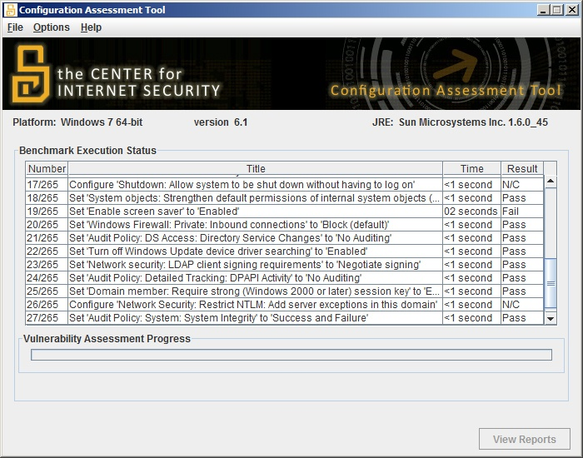 *Screenshot of CIS-CAT Lite performing an audit of Windows 7*

We suggest the use of [CIS-CAT Lite](https://www.cisecurity.org) as it is free, very simple, cross platform tool that individuals can use to quickly assess the security of the configuration on the devices they are using.

As participants to record on post-it notes the score that they get.

## Discussion

* What assets to we have in the training room?
* How can we keep track of them?
* What basic standards do we expect to meet?
* What standard of information security do we know about?
* How many of us have used these standards?
* How can we measure our standards?
* What scores did our devices get on the benchmark test?
* What configuration problems where the most common?
* How comfortable would we feel to fix the main problems that have been identified?

## Inputs

There are a number of different types of standard, developed by multiple organisations that may apply or be useful for the work that Champions do.

For example:

* Centre for Internet Security (CIS)
* International Organization for Standardization (ISO)
* National Institute of Standards and Technology (NIST)
* Open Web Application Security Project (OWASP)
* Payment Card Industry (PCI)
* Security Auditing Framework and Evaluation Template for Advocacy Groups (SAFETAG)

Each of these standards addresses different issues and works in different ways. For example some of them:

* Focus on device and networks, others on processes or websites, and applications.
* Can be more automated and can be mostly conducted with specific tools.
* Need a lot of human inputs but gather a more comprehensive picture of an organisation
* Require a specfic auditor be trained for an audit to be official
* Can take a significant amount of time, cost and resources to fully conduct

## Deepening

***Other types of auditing*** There a number of different types of tools and techniques that can be used for helping conduct audits of organisations.

These include:

* Mapping Tools - such as NMAP, Angry IP Scanner
* Vulnerabilty Scanners - such as Nessus, Nexpose and Openvas.
* Vulnerability Expoit Tools - such as Metasploit, Immunity Canvas
* Configuration Benchmarking Tools - such as CIS-CAT, Openscap, Microsoft Security Compliance Manager
* Inventory and Asset Managers - Snipe-IT, Open-AudIT

***SAFETAG***  
Developed by Interews, SAFETAG is a standard specifically designed for meeting the unique needs of the civil society community. It covers how to conduct a full audit of a organisation and is flexible to deal with the technical capabilities and risks that they groups may face. However it does require being comfortable with a number of tools and processes.

For many Champions on this course who implement the basic assessment they create, SAFETAG would be an excellent training and auditing goal for themselves and their organisations.

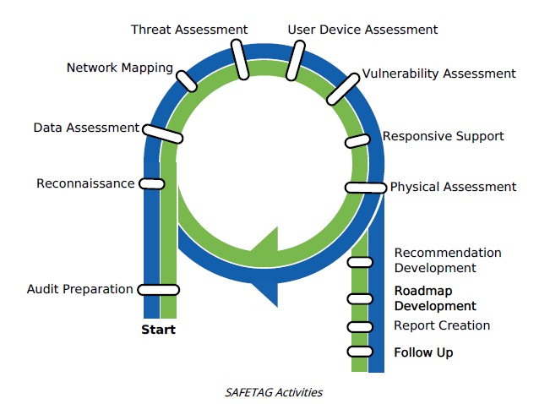 *The SAFETAG audit framework*

## Synthesis

Participants should turn to their assessment documentation and consider how their organisation deals with the subject matter covered in this module. Where necessary they should ask questions and work with other participants to identify any:

* Issues they have found that effect their organisations
* Possible solutions they have learned
* Possible difficulties they may face in implementation (ideally using the time ad experience of trainers and other participants)
* Things would need to overcome these difficulties
* Connections to other organisations or individuals that would help them
* Timeline, resources and costs for implementation

This should be noted in their assessment, for future use.

In line with keeping this curriculum as an updated community tool, we would also ask that participants provide comments, feedback and new ideas for this module on the project website and/or Github!

## Resources

# Community Structures and Resources for further learning

### Introduction

This course is has only covered the basics of a large variety of topics, many of which could be a whole course in itself. The information security environment is also changing on a daily basis and it is impossible for any lone individual to keep up with the latest news, tools etc. However there is a wider community that Champions should feel part of, beginning with those in the room. This course highlights some of these organisations and structures and explores ways to ensure Champions feel able to be an active part of both using and helping this community to develop.

-This is just a stepping stone -A much wider community -Inputs are needed -Reach out and keep current -Create own networks

### Learning Goals

* Participants have a full overview of the sources of support they can avail of
* Pathways and resources for future learning - system admin, ethical hacking, forensics etc.

### Assessment Goals

* Participants have connected to the organisations or structures of most relevance to their work

### Recommend Preparations

### Suggested Time

25 Minutes

### Notes

N/A

## Activity

## Discussion

* Why would it be useful to share?
* What structures, groups, organisations, people (offline and online) do we already use to share information, keep informed and learn from?
* What would we want to share? (e.g. advice, new methods, indicators of compromise, new tools etc.)
* How can we create a structure from the people here in the room?
* How much would we want to share? ## Inputs Lists of useful sources - listserves etc

## Deepening

Setup an agreed and secure method of sharing within the group, if that is something that the group wishes to do.

## Synthesis

Participants should turn to their assessment documentation and consider how their organisation deals with the subject matter covered in this module. Where necessary they should ask questions and work with other participants to identify any:

* Issues they have found that effect their organisations
* Possible solutions they have learned
* Possible difficulties they may face in implementation (ideally using the time ad experience of trainers and other participants)
* Things would need to overcome these difficulties
* Connections to other organisations or individuals that would help them
* Timeline, resources and costs for implementation

This should be noted in their assessment, for future use.

In line with keeping this curriculum as an updated community tool, we would also ask that participants provide comments, feedback and new ideas for this module on the project website and/or Github!

-Have them propose the resources and support networks they use. Especially for localised help. -Help them create organic support networks with the people in the room where possible. Suggest structure, method, timing etc.

## Resources

# Basic Assessment Appendix

Each module of this course had recommended assessment goals. The aim of these is to help each individual:

* Take notes on useful information they have learned throughout the course
* Benefit from from the unwritten peer learning that they gain during group work and conversations
* Have a starting point for increasing the security of the organisations that they are working with

The suggested basic assessement questions are examples and participants should feel free add/remove information on each module that they feel will be relevant. While filling out this assessment in a digital format is recommended, we suggest that any participants take security precautions to protect it's sensitive information.

## [Mapping information, assessing the threat environment and modelling](mapping.md)

* Create an information map for your organisation
* Add generic and localised threat resources (where available) that you can use to be able to measure risk in your specific circumstances
* Develop an easily understandable information security traffic light map with corresponding mitigation measures for your organisation

## [Privacy regulation and requirements](privacy.md)

* Which legal and other best practice policies affect your organisation?
* What actions must your organisation take to be able to meet these requirements?

## [User Education](education.md)

* What new techniques and tools can you use to enhance user education within your organisation?
* What techniques and tools and can you use to measure implementation of user education within your organisation?

## [Encryption, Patching, Licensing](encryption.md)

* What is the current status of encryption, patching and licensing across your organisation?
* How can encryption, patching and licensing be better managed across your organisation?
* If you don't already have one, can you benefit from a relationship with an organisation that provides discounts for non-profits such as TechSoup
* What would be the rough costs or resources needed to implement new software or services for security management into your organisation?

## [Network Management, Monitoring and Logs](network.md)

* Draw a map of your current infrastructure and architecture
* What tools and techniques could be used for better monitoring of security risks and logs within your organisation?
* What steps would you need to take to implement better security monitoring within your organisation?

## [Communications](communications.md)

* Develop a communications plan for your organisation based on the scenarios they face - day to day, internal, first contact, working with partners etc.

## [Web and Email Management](webandemail.md)

* Add any necessary changes to security and privacy features your their organisations email service
* Add any necessary changes to your organisation's web hosting service (e.g. Wordpress) that you need to increase security.
* Add DDoS protection service (if needed)

## [Password Management](passwords.md)

* Add your organisation's recommended tool for password management - including resources useful for teaching. Even if the tool is individual (e.g. KeepassXC) vs. centrally managed
* Identify any services your organisation uses that allow for two factor authentication but are not already enabled
* What steps might be necessary within your organisation for implementing better management of passwords?

## [Mobile Device Management / BYOD](byod.md)

* What would a policy for MDM/BYOD for your organisation neeed to contain?
* If you don't already have one, what MDM/BYOD tools might work best for your organisation?

## [Travel](travel.md)

* During what times or in what locations are people within your organisation most at risk during travel?
* What basic travel security advice are you most likely going to have to give to people within your organisation?
* If you don't already have one, list the main features you will need in a travel security policy.

## [Resilience and Backups](resilience.md)

* If you don't already use one, which backup solution might be best for your organisation?
* Write a short business continuity process and plan

## [Policy Creation and Implementation](policy.md)

* What policies are my organisation missing?
* What templates can I use to build policies?
* List the main likely obstacles to implementation within their organization and their corresponding potential solutions

## [Physical Security](physical.md)

* What physical controls might I need to add to my own home/office environment?

## [Responding to Incidents](incidents.md)

* What types of incidents do I expect that my organisation may face?
* Who else needs to be involved in responding to an incident? (e.g hosting provider, social media manager, partner organisations)
* What is my incident response plan for major information security risks?

## [Basic audits](audits.md)

* What tools and resources can I use for basic auditing within my organisation?
* What regular checks and basic audit will I do on a regular cycle?
* What steps to I need to take to ensure I regularly conduct a basic audit?
* How can I ensure that issues identified in the basic audit are addressed?

## [Community structures and resources for further learning](community.md)

* What new community structures can I use?
* When and and how can I connect to them?
* What can they provide?
* What can I provide back to the community?

## Top 10 Things I am going to do this week

## Top 10 Things I am going to do this month

## Top 10 Things I am going to do this year

## Notes